

**UNIVERSITY OF GREENWICH**  
COMP-1640-M02-2022-23

Enterprise Web Software Development

Group Report

Coursework

|  |  |
| --- | --- |
| Student name | To Nhat Duy |
| ID number (00xxxxxxx) | 001272680 |
| Lecturer/Tutor name | LE THANH HUY |
| Student submission date | 04/19/2023 |

**Team name:** Group VPQD

**Table 1:** Team member + Positions + Commitment point

|  |  |  |  |
| --- | --- | --- | --- |
| **Member’s name** | **ID** | **Roles** | **Commitment point (0-10)** |
| Tran Quan Vinh (Leader) | 001272758 | Scrum master - Fullstack |  |
| Truong Van Phat | 001272727 | Product Owner - Tester |  |
| Nguyen Huynh Hong Quan | 001272731 | Frontend - Tester |  |
| To Nhat Duy | 001272680 | Database designer - Tester |  |

**Table 2:** Roles account

|  |  |  |
| --- | --- | --- |
| **Roles** | **Email** | **Password** |
| QA (Admin) | [admin@gmail.com](mailto:admin@gmail.com) | 123456 |
| Staff | [staff@gmail.com](mailto:staff@gmail.com) | 123456 |

**Table 3:** URL

|  |  |
| --- | --- |
| URL of the screencast | https://drive.google.com/file/d/1Iw3kGEb03CF-b372NiL3dem9TjRLFAq6/view?usp=sharing |
| URL of repository | <https://github.com/VinhTranQuan/1640-code/tree/main/Idea_Management> |

**Table of Contents**

**1.** **Introduction** 9

**2.** **Database** 9

**2.1.** **Entity-relationship diagram (ERD)** 9

**2.1.1.** **“Account” entity** 10

**2.1.2.** **“Feedback” entity** 11

**2.1.3.** **“Post” entity** 11

**2.1.4.** **“Category” entity** 12

**2.1.5.** **“Department” entity** 12

**2.1.6.** **“Comment” entity** 13

**2.1.7.** **Relationship between entities** 13

**2.2.** **Database design** 19

**3.** **Interface design** 21

**3.1.** **Site map system** 21

**3.2.** **Final designs** 22

**4.** **Functionality** 35

**4.1.** **Use case diagram** 35

**4.1.1.** **Admin** 35

**4.1.2.** **Staff** 36

**4.2.** **Activity diagram** 37

**4.2.1.** **Admin** 37

**4.2.2.** **Staff** 52

**4.3.** **Demo function** 57

**5.** **Testing** 76

**5.1.** **Testing scope** 76

**5.2.** **Test details** 76

**5.2.1.** **Sprint 1** 78

**5.2.2.** **Sprint 2** 79

**5.2.3.** **Sprint 3** 80

**5.2.4.** **Sprint 4** 82

**5.2.5.** **Sprint 5** 84

**5.2.6.** **Sprint 6** 85

**6.** **Agile Scrum implementation** 87

**6.1 Product backlog** 87

**6.2 Sprint backlogs** 88

**6.2.1 Sprint 1** 89

**6.2.1 Sprint 2** 91

**6.2.3 Sprint 3** 93

**6.2.4 Sprint 4** 95

**6.2.5 Sprint 5** 97

**6.2.6 Sprint 6** 100

**6.3 Minute of daily meeting** 102

**6.3.1 Sprint 1** 102

**6.3.2 Sprint 2** 102

**6.3.3 Sprint 3** 103

**6.3.4 Sprint 4** 103

**6.3.5 Sprint 5** 104

**6.3.6 Sprint 6** 105

**7.** **References** 106

**List of Figure**

**Figure 1:** ERD 9

**Figure 2:** “Account’ entity 10

**Figure 3:** “Feedback” entity 11

**Figure 4:** “Post” entity 11

**Figure 5:** “Category” entity 12

**Figure 6:** “Department” entity 12

**Figure 7:** “Comment” entity 13

**Figure 8:** “account” and “comment” relationship 13

**Figure 9:** “account” and department relationship 14

**Figure 10:** “account” and “feedback” relationship 15

**Figure 11:** “account” and “post” relationship 15

**Figure 12:** “feedback” and “post” relationship 16

**Figure 13:** “feedback” and “department” relationship 17

**Figure 14:** “feedback” and “comment” relationship 17

**Figure 15:** “post” and “department” relationship 18

**Figure 16:** “post” and “category” relationship 19

**Figure 17:** “account” entity 19

**Figure 18:** “category” entity 20

**Figure 19:** “comment” entity 20

**Figure 20:** “department” entity 20

**Figure 21:** “feedback” entity 21

**Figure 22:** “post” entity 21

**Figure 23:** Site map system 21

**Figure 24:** Login 22

**Figure 25:** Login with admin account 23

**Figure 26:** Post interface 23

**Figure 27:** Create post interface 24

**Figure 28:** Edit post interface 24

**Figure 29:** Delete post interface 25

**Figure 30:** Category interface 25

**Figure 31:** Add category 26

**Figure 32:** Delete category 26

**Figure 33:** Staff interface 27

**Figure 34:** Add staff 27

**Figure 35:** Edit staff interface 28

**Figure 36:** Delete staff interface 28

**Figure 37:** Department interface 29

**Figure 38:** Add department 29

**Figure 39:** Edit department 30

**Figure 40:** Delete department interface 30

**Figure 41:** QA list interface 31

**Figure 42:** Update profile interface 31

**Figure 43:** Change password interface 32

**Figure 44:** Interface when logged in with staff account 32

**Figure 45:** View post and feedback interface 33

**Figure 46:** Submit idea interface 33

**Figure 47:** List feedback interface 34

**Figure 48:** Comment and like interface 34

**Figure 49:** Usecase diagram (Admin) 35

**Figure 50:** Usecase diagram (Staff) 36

**Figure 51:** Update account activity 37

**Figure 52:** Change password activity 38

**Figure 53:** Add department activity 39

**Figure 54:** Edit department activity 40

**Figure 55:** Delete department activity 41

**Figure 56:** Add post activity 42

**Figure 57:** Edit post activity 43

**Figure 58:** Delete post 44

**Figure 59:** Add category activity 45

**Figure 60:** Edit category activity 46

**Figure 61:** Delete category activity 47

**Figure 62:** Add staff activity 48

**Figure 63:** Edit staff activity 49

**Figure 64:** Delete staff activity 50

**Figure 65:** Writing feedback 51

**Figure 66:** Update account activity 52

**Figure 67:** Change password 53

**Figure 68:** Add idea 54

**Figure 69:** Edit idea 55

**Figure 70:** Delete idea 56

**Figure 71:** Login interface 57

**Figure 72:** Login with admin account 57

**Figure 73:** After login with admin account 58

**Figure 74:** Category interface 58

**Figure 75:** Add category 59

**Figure 76:** Add category information 59

**Figure 77:** Show category information 60

**Figure 78:** Delete category 60

**Figure 79:** Department interface 61

**Figure 80:** Create department interface 61

**Figure 81**: Add department information 62

**Figure 82:** Show department information 62

**Figure 83:** Edit department 63

**Figure 84:** Delete department 63

**Figure 85:** Staff interface 64

**Figure 86:** Create staff interface 64

**Figure 87:** Create staff information 65

**Figure 88:** Show staff information 66

**Figure 89:** Edit Staff 66

**Figure 90:** After edit staff 67

**Figure 91:** Delete staff 67

**Figure 92:** Post interface 68

**Figure 93:** Create post 68

**Figure 94:** Add post information 69

**Figure 95:** Show post information 69

**Figure 96:** Edit post interface 70

**Figure 97:** After edit post 70

**Figure 98:** Delete post 71

**Figure 99:** QA list interface 71

**Figure 100:** Staff interface 72

**Figure 101:** View post and feedback interface 72

**Figure 102:** Submit idea information 73

**Figure 103:** Idea information interface 73

**Figure 104:** Idea information interface with admin account 74

**Figure 105:** Comment idea interface 74

**Figure 106:** After comment and like idea 75

**Figure 107:** Update profile 75

**Figure 108:** Change password interface 76

**Figure 109:** Burndown chart of sprint 1 90

**Figure 110:** Burndown chart of sprint 2 92

**Figure 111:** Burndown chart of sprint 3 94

**Figure 112:** Burndown chart of sprint 4 96

**Figure 113:** Burndown chart of sprint 5 99

**Figure 114:** Burndown chart of sprint 6 101

**List of Table**

**Table 1:** Team member + Positions + Commitment point 2

**Table 2:** Roles 2

**Table 3:** URL 2

**Table 4:** Test sprint 1 78

**Table 5:** Test sprint 2 79

**Table 6:** Test sprint 3 80

**Table 7:** Test sprint 82

**Table 8:** Test sprint 5 84

**Table 9:** Test print 6 85

**Table 10:** Product backlog 87

**Table 11:** Sprint 1 89

**Table 12:** Sprint 2 91

**Table 13:** Sprint 3 93

**Table 14:** Sprint 4 95

**Table 15:** Sprint 5 97

**Table 16:** Sprint 6 100

**Table 17:** Daily meeting sprint 1 102

**Table 18:** Daily meeting sprint 2 102

**Table 19:**Daily meeting sprint 3 103

**Table 20:**Daily meeting sprint 4 103

**Table 21:**Daily meeting sprint 5 (1) 104

**Table 22:**Daily meeting sprint 5 (2) 104

**Table 23:** Daily meeting sprint 6 105

**Table 24:** Daily meeting sprint 6 (2) 105

# **Introduction**

This team report is intended to document the development of a website application based on the given specifications. The report is divided into four main sections detailing the project phases. First, we'll cover creating a database for the site, highlighting key entities and stages from pre-normalization to a third normalization. Second, we will present the user interface design, outlining the three main phases including drawing the site map, developing the prototype, and designing the final interface. The third part will give an overview of the main functions of the website based on a detailed case study of different users, specifically QA, department manager and staff. The testing phase, which is very important to ensure functionality, will be presented, including all the conducted test cases and their results. Finally, we will discuss the Agile Scrum methodology used during the development of this project.

# **Database**

## **Entity-relationship diagram (ERD)**

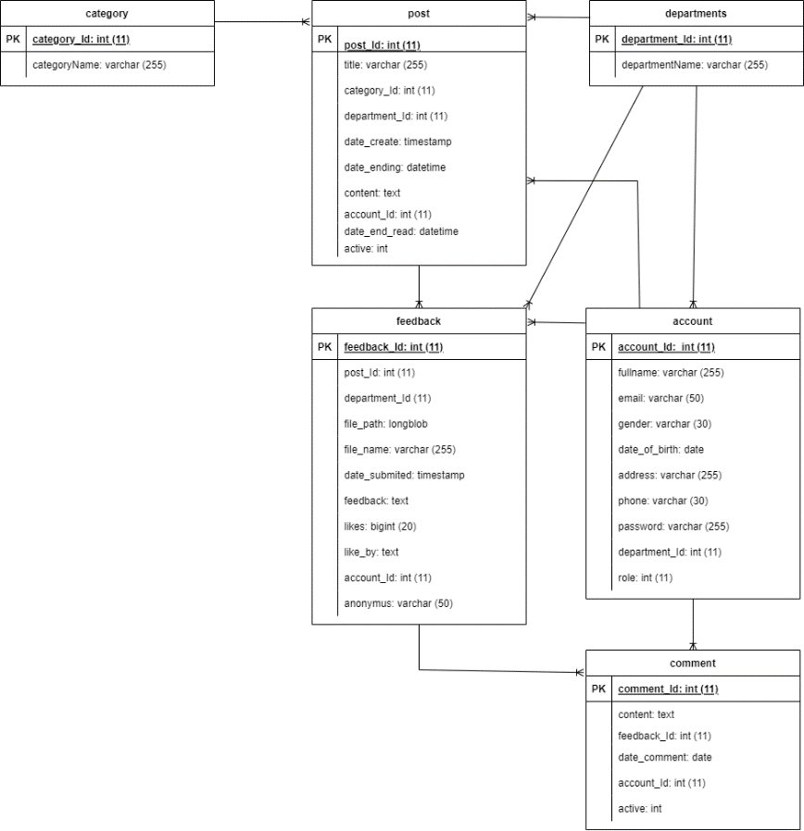

**Figure 1:** ERD

**Explain:** The project's database is comprised of six tables, with their respective entities and relationships visually represented in Figure 1. Each entity and its corresponding relationship will be meticulously outlined in detail below.

### **“Account” entity**

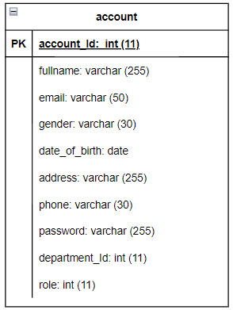

**Figure 2:** “Account’ entity

**Explain:** The primary objective of creating this entity is to facilitate the efficient management of account user details on a database. The entity comprises ten key attributes, including account identification (account_Id), full name (fullname), email address (email), gender, date of birth (date_of_birth), physical address (address), phone number (phone), password, department identification (department_Id), and role information. Overall, this entity plays a crucial role in simplifying the account information storage process.

### **“Feedback” entity**

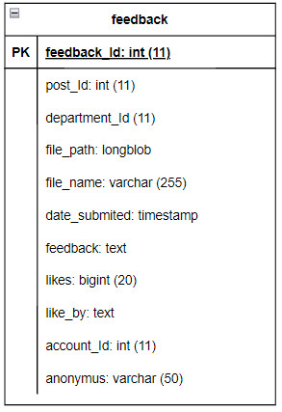

**Figure 3:** “Feedback” entity

**Explain:** The primary function of this entity is to facilitate the organization and storage of employee comments on QA posts in a database. It comprises of 11 principal properties that include feedback_Id, post_Id, department_Id, file_path, file_name, date_submited, feedback, likes, like_by, account_Id, and anonymus. These properties serve to streamline the management process of the feedback, providing an efficient means of accessing and handling the data.

### **“Post” entity**

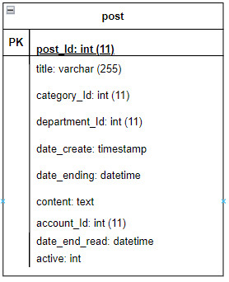

**Figure 4:** “Post” entity

**Explain:** This entity plays a crucial role in streamlining the response management process by facilitating the efficient organization and storage of QA posts in the database. It is comprised of eight key attributes, including the post's title, post ID, department ID, category ID, creation date, expiry date, content, and account ID. These attributes work together to provide a seamless means of accessing and processing data, ultimately enhancing the overall efficiency of the response management process.

### **“Category” entity**

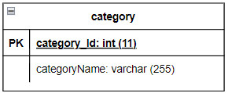

**Figure 5:** “Category” entity

**Explain:** This entity serves as a means to streamline the organization of post types and their storage in the database. Its two key attributes, category_Id and categoryName, aid in the effective processing of data by simplifying the response management process. This facilitates the efficient access and retrieval of data, contributing to a more streamlined and optimized system.

### **“Department” entity**

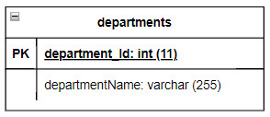

**Figure 6:** “Department” entity

**Explain:** This entity is designed to simplify the management of department types and their storage in a database. It is characterized by two key properties: department_Id and departmentName. These properties help to streamline the handling of data by simplifying the process of managing responses. This, in turn, facilitates efficient access to and retrieval of data, leading to a more optimized and streamlined system.

### **“Comment” entity**

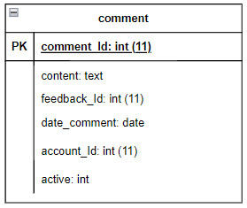

**Figure 7:** “Comment” entity

**Explain:** The purpose of this entity is to make the management of comment types in staff’s idea easier and store them in the database. It has five primary attributes: comment_Id, content, feedback_Id, date_comment, and account_Id. These attributes help simplify data processing by making response management more efficient, leading to faster data access and retrieval. As a result, the system becomes more streamlined and optimized.

### **Relationship between entities**

* “account” and “comment” relationship

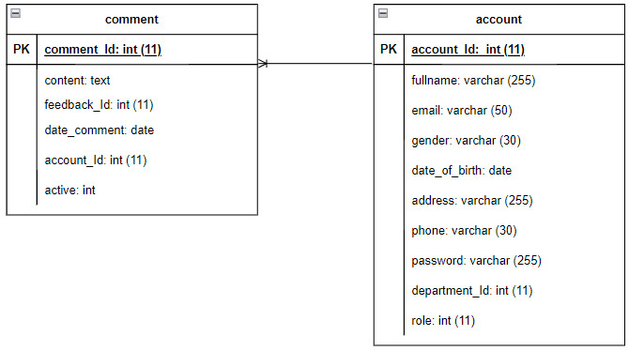

**Figure 8:** “account” and “comment” relationship

**Explain:** The `account` table contains information about the user accounts registered or used for the application or website. Meanwhile, the `comments` table contains information about comments posted by users on a certain content or article. On the relational side, the `comments` table is linked to the `account` table via the `account_Id` foreign key, which means that each comment will be linked to the user account that posted or used to log in and post comments. that argument. An account (account) can create many comments (comments). Each comment must belong to a specific account.

* “account” and “department” relationship

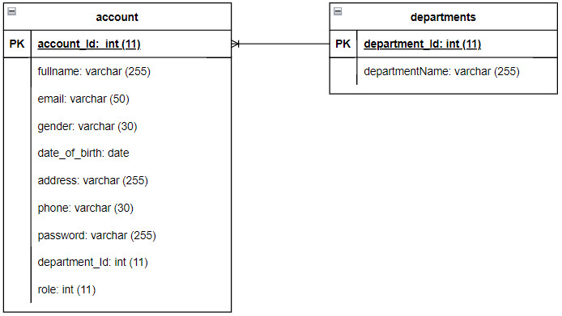

**Figure 9:** “account” and department relationship

**Explain:** Tables `accounts` and `departments` have a one-to-many relationship (one-to-many relationship). This means that a department can have many accounts, but one account belongs to only one department. To display this relationship, the table `department` has the primary keyword `department_id`, then the table `accounts` has the field `department` as a foreign keyword referencing the table `department`. Using exceptions allows us to link the records in these two tables together, making querying and data management more convenient.

* “account” and “feedback” relationship

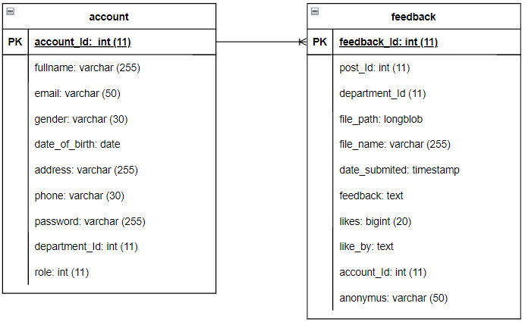

**Figure 10:** “account” and “feedback” relationship

**Explain:** The account and feedback tables have a one-to-many relationship. This means that each account (account) can have many feedback (feedback), but each response can only belong to 1 account. To show this relationship, the account table has a primary key of id (representing each account), and the feedback table has a primary key of feedback_id (representing each response). However, the feedback table also has an account_id field to store the foreign key of the account table, associated with the account to which the response belongs.

* “account” and “post” relationship

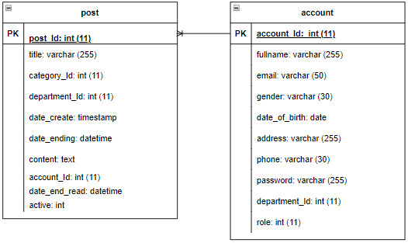

**Figure 11:** “account” and “post” relationship

**Explain:** The relationship between the account and post tables is an entity-association relationship in the database. On a simple database, the account table typically contains information about a user account such as name, email address, password, and other fields of information. Meanwhile, the posts table contains information about the posts on the website, such as title, content, date of publication, poster and other fields. The relationship between these two tables is one-to-many, which means that each user account can post multiple posts on the site. Each post is posted by a single account and each account can post multiple posts. Therefore, in order to display the posts on the site, the information from both tables must be combined using a common primary key. In this case, information about the user account will be stored in the account table and information about the posts will be stored in the posts table. Each post will be identified with a unique number, and all of these posts will contain an ID value corresponding to the user account it was posted by.

* “feedback” and “post” relationship

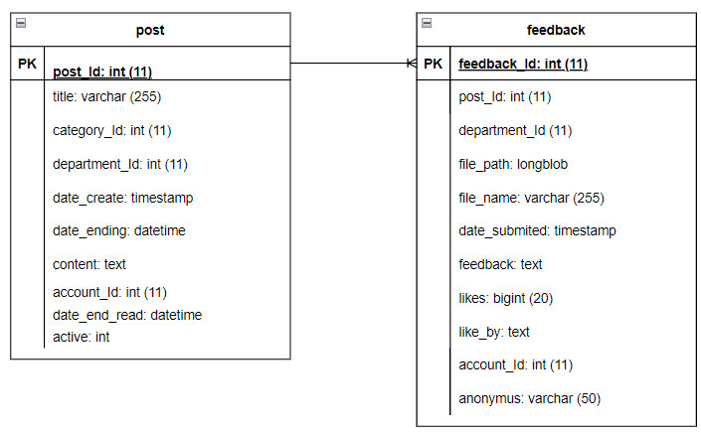

**Figure 12:** “feedback” and “post” relationship

**Explain:** The relationship between the Feedback and Post tables is a one-to-many relationship. This means that a post can have multiple feedback votes, but a vote can only belong to one post. In the database, to establish this relationship, the Feedback table will have a foreign key that refers to the primary key of the Post table. This allows the feedback sheets to be linked to the corresponding article. This relationship allows to manage user responses to articles, and to track and display user responses on specific articles.

* “feedback” and “department” relationship

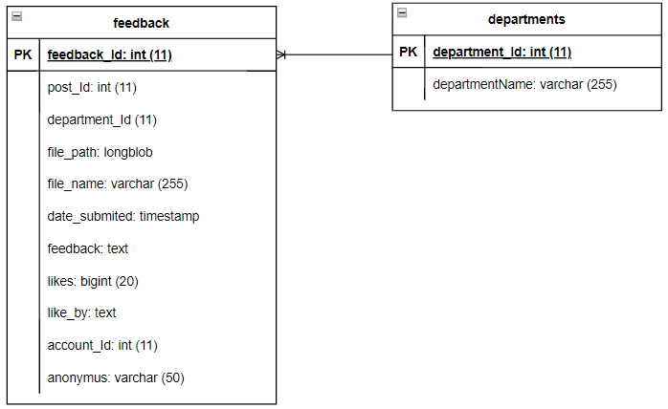

**Figure 13:** “feedback” and “department” relationship

**Explain:** The relationship between the two response tables and the department is a many (one-to-many) relationships, where a department can have many responses. This relationship is represented by a foreign key in the response table, which points to the primary key of the parts table that identifies the data unit of the response. A department (department) can have many different responses (responses) from many users Each response is in the data unit of a particular department The relationship between the two tables can be represented via foreign key (foreign key) department_Id in response table, pointer to primary key (primary key) id of table department.

* “feedback” and “comment” relationship

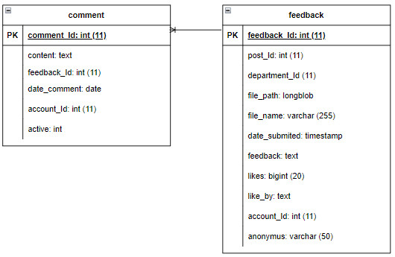

**Figure 14:** “feedback” and “comment” relationship

**Explain:** The "feedback" and "comments" tables have a one-to-many relationship. That is, a version in “feedback” can have many comments, but that one comment can only correspond to one "feedback". Specifically, the "feedback" table contains information about user feedback, such as feedback_Id, feedback, creation date and creator. Meanwhile, the "comments" table contains user comments on a particular response, including the id_comment, body, creation date, creator, and feedback_Id associated with the corresponding response.

* “post” and “department” relationship

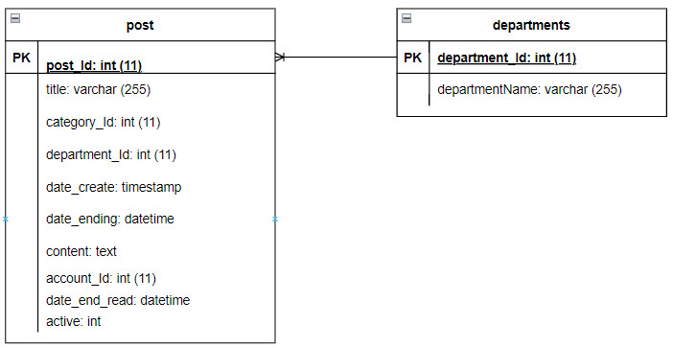

**Figure 15:** “post” and “department” relationship

**Explain:** The relationship between the post and department tables can be a "one-to-many" relationship. This means that each post only belongs to a certain department. However, each department can contain multiple posts. In the database, to represent this relationship, we can add a field "department_Id" to the table "posts", representing the department to which the post belongs. This field will act as the foreign key referring to the primary key of the "department" table, allowing us to easily retrieve related information between the two tables.

* “post” and “category” relationship

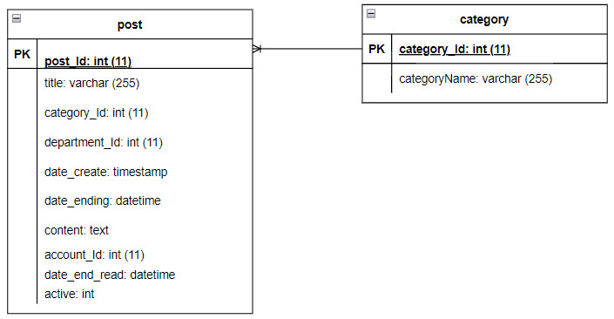

**Figure 16:** “post” and “category” relationship

**Explain:** The relationship between the post and category tables can be a "one-to-many" relationship. This means that each post has only a certain type. However, each category can belong to multiple posts. In the database, to represent this relationship, we can add a field "department_Id" to the table "posts", representing the department to which the post belongs. This field will act as a foreign key that refers to the primary key of the "department" table, allowing us to easily retrieve related information between the two tables.

## **Database design**

* “account” entity

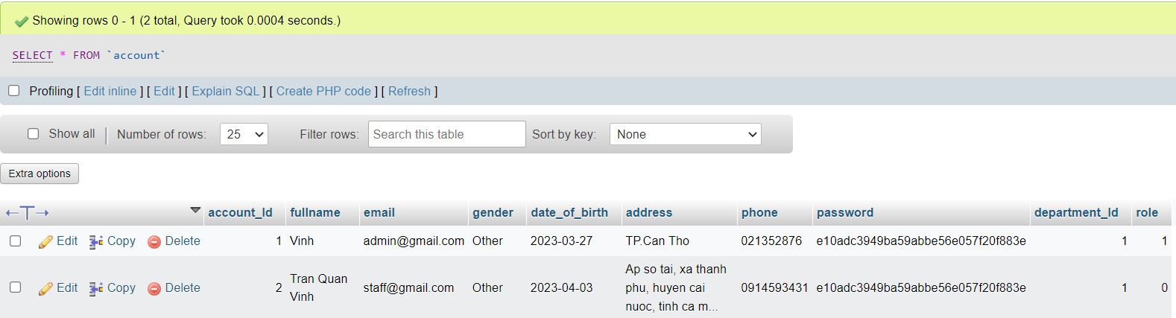

**Figure 17:** “account” entity

* “category” entity

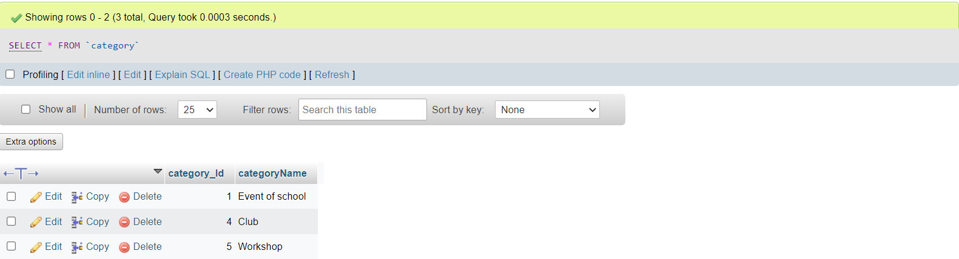

**Figure 18:** “category” entity

* “comment” entity

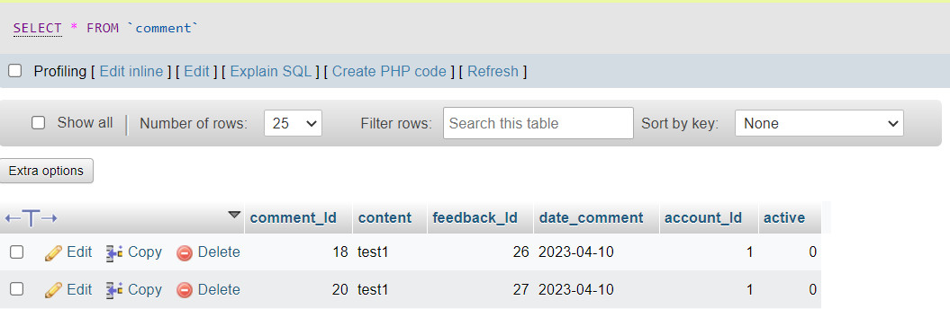

**Figure 19:** “comment” entity

* “department” entity

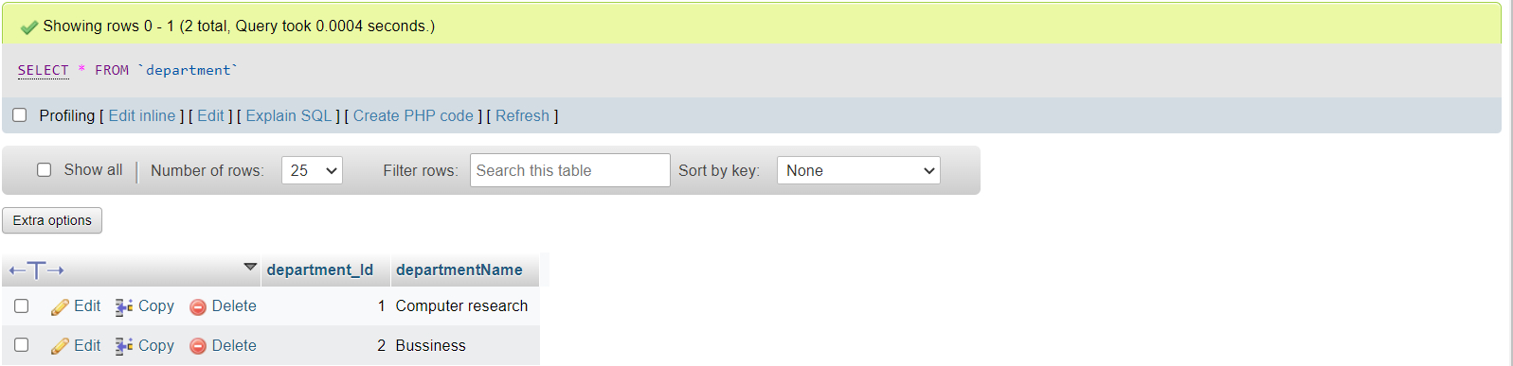

**Figure 20:** “department” entity

* “feedback” entity

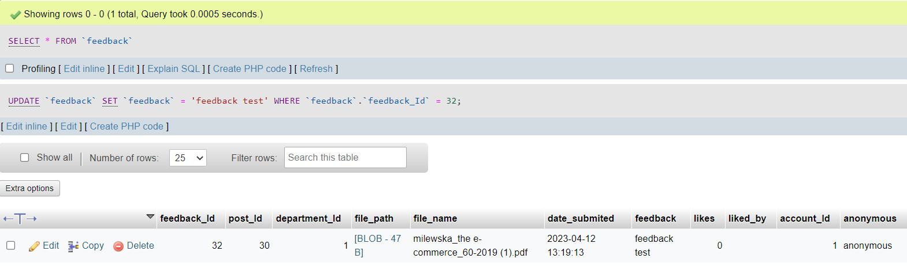

**Figure 21:** “feedback” entity

* “post” entity

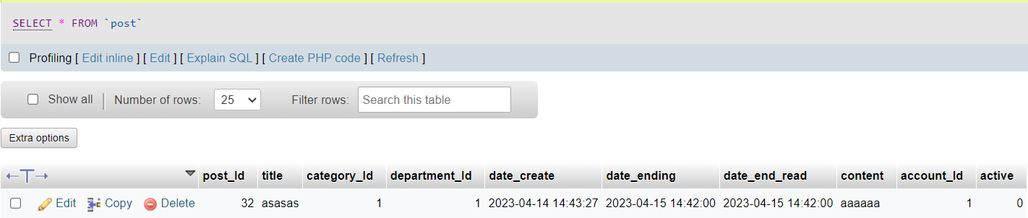

**Figure 22:** “post” entity

# **Interface design**

## **Site map system**

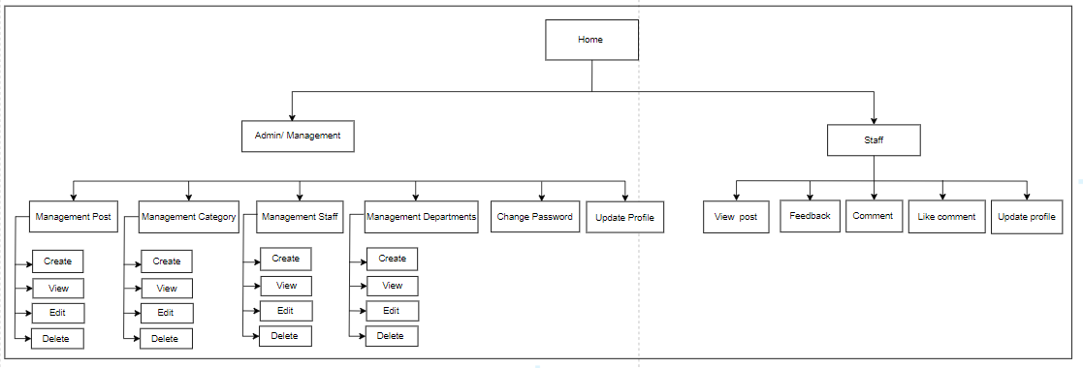

**Figure 23:** Site map system

The website system has been scientifically designed to ensure that the management becomes easier and more convenient than ever. The homepage of the website will be the Home page, where users can view basic information and learn about the website. However, to manage the website professionally, the system has been decentralized into two main objects, Admin and Staff. Admin will be granted access to the main management sections including: article management, staff management, department management and category management. For each management section, users will be provided with basic functions such as adding, editing and deleting to easily manage the content and information of the website. In addition, in the admin management section, there are additional functions to manage your own profile such as changing passwords and updating personal information. Meanwhile, Staff will be allowed to access and use basic functions including viewing posts, giving feedback, leaving comments, liking comments and updating personal information. These functions will be clearly and easily divided so that each user can use and access easily quickly and conveniently. At the same time, the system will provide users with detailed help and instructions to help them use the website most effectively.

## **Final designs**

* **Login**

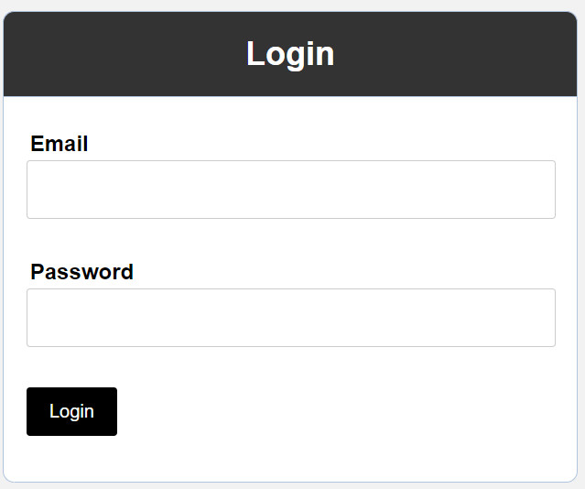

**Figure 24:** Login

This is the login interface of the system, in this page will ask the user of his account to log in to the system.

* **Logged in with admin account**

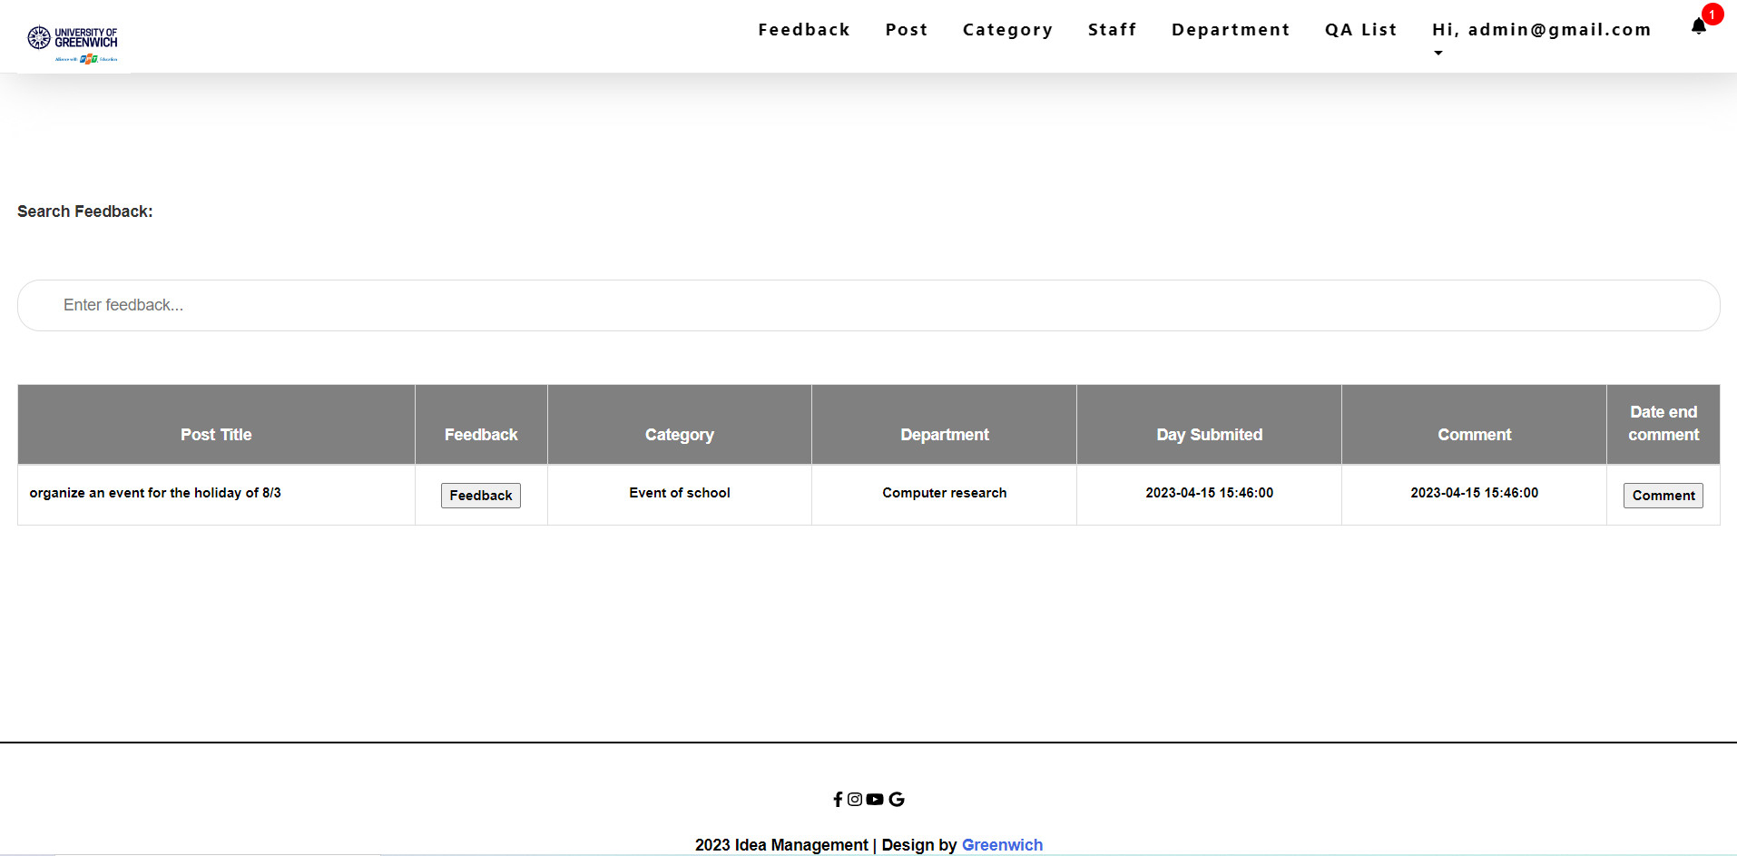

**Figure 25:** Login with admin account

This is the interface after the admin has successfully logged into the system

* **Post interface**

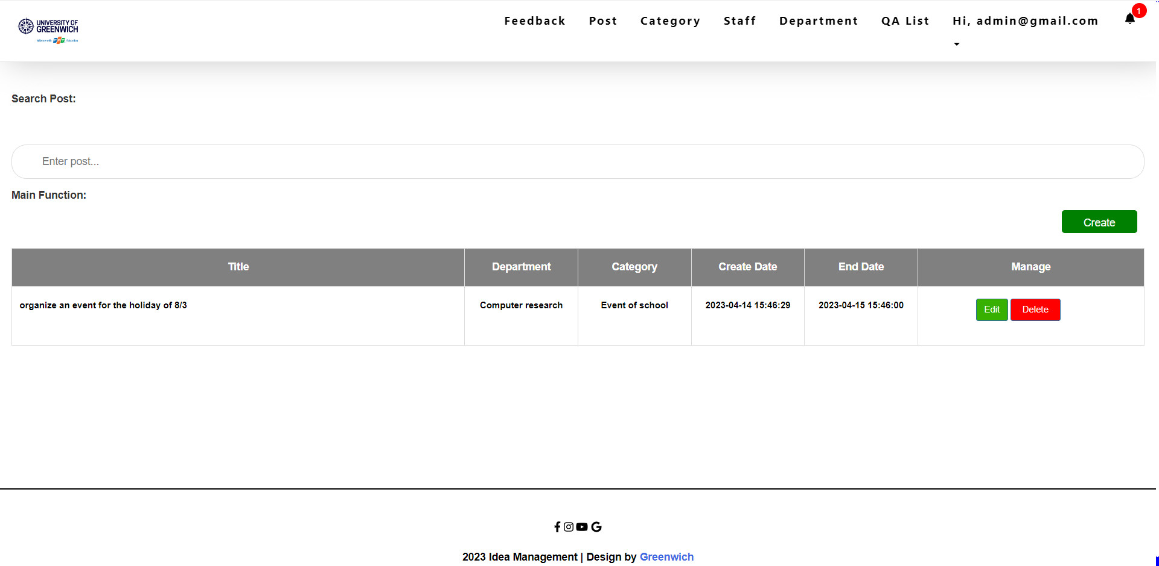

**Figure 26:** Post interface

This is the Post interface, which in this page belongs to the administrator's control. In this section, the administrator will perform tasks such as adding, editing, and deleting posts.

* **Create post interface**

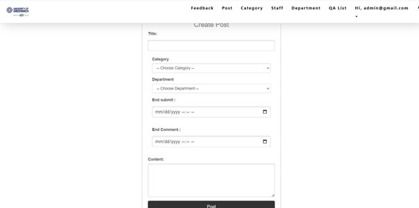

**Figure 27:** Create post interface

This is the interface to add a new post, in this page will display the necessary information to create a new post.

* **Edit post interface**

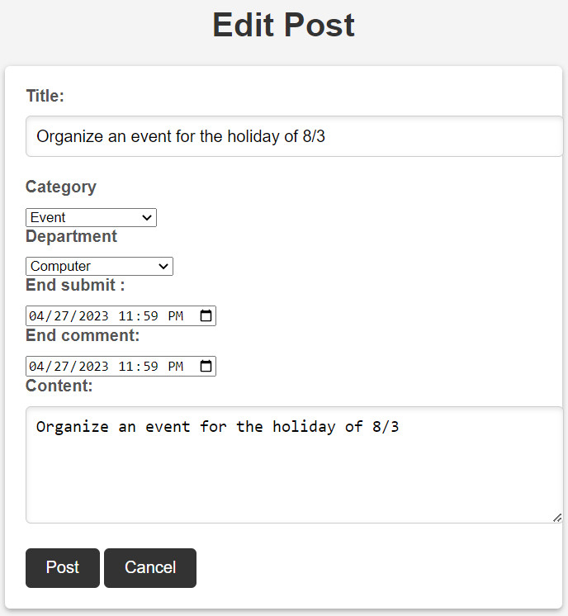

**Figure 28:** Edit post interface

This is the post editing interface, in this page will display the information of a post so that the admin wants to edit any information of that post.

* **Delete post interface**

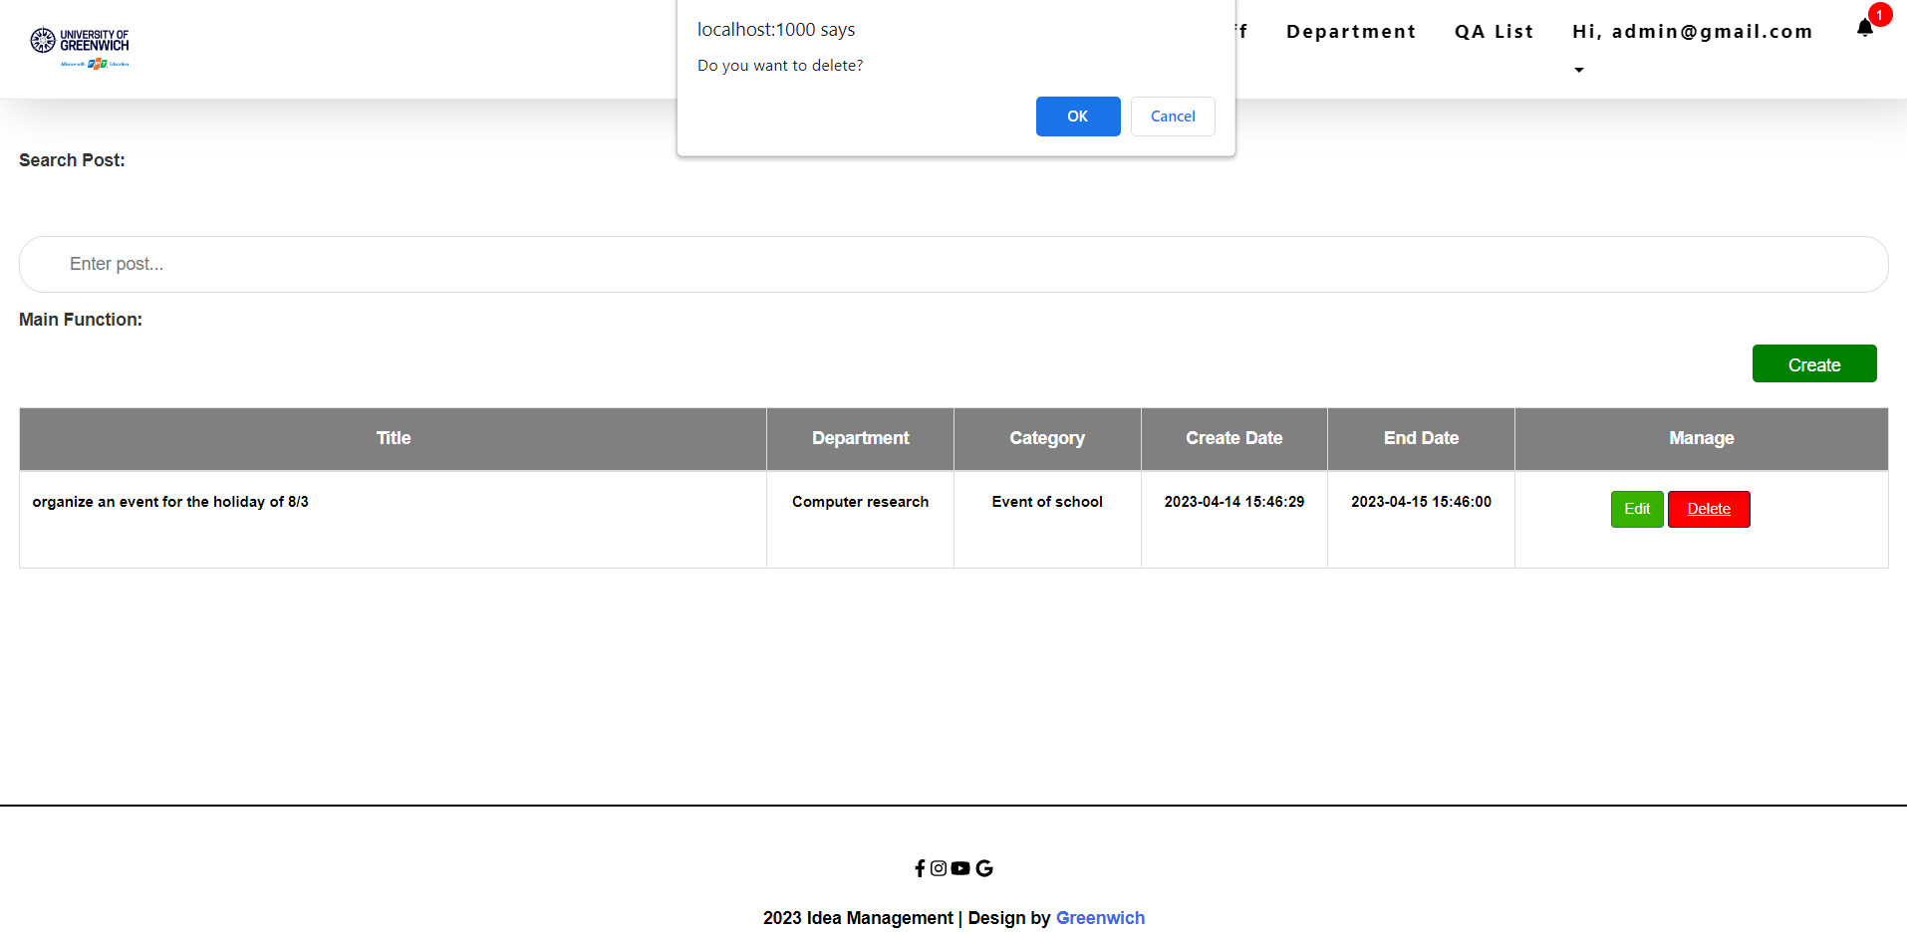

**Figure 29:** Delete post interface

This is the interface to delete a post, in this part the system will display a message to confirm that the administrator wants to really delete the post or not. If you choose Ok, the system will delete it, if you choose Cancel, you will return to the Post page

* **Category interface**

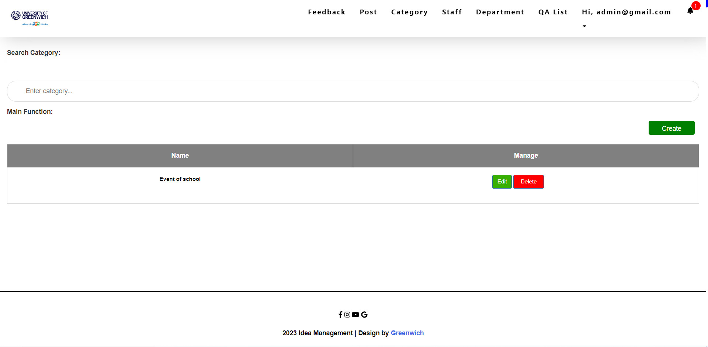

**Figure 30:** Category interface

This is the Category interface, which in this page belongs to the administrator's control. In this section, the administrator will perform tasks such as adding and deleting category.

* **Add category interface**

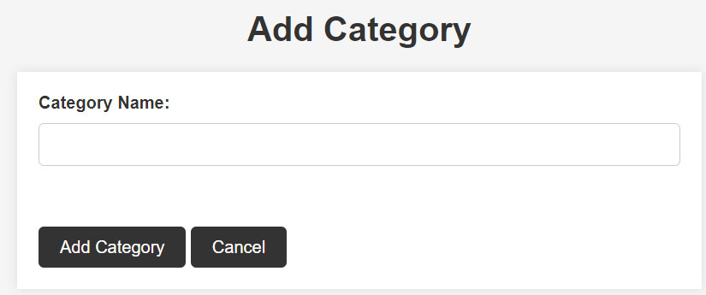

This is the interface to add a new category, in this page will display the necessary information to create a new category

**Figure 31:** Add category

* **Delete category interface**

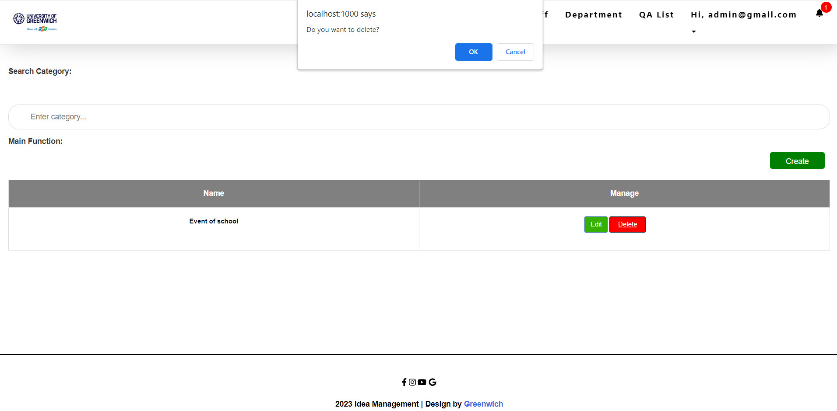

**Figure 32:** Delete category

This is the interface to delete a category, in this part the system will display a message to confirm that the administrator wants to really delete the category or not. If you choose Ok, the system will delete it, if you choose Cancel, you will return to the Category page.

* **Staff interface**

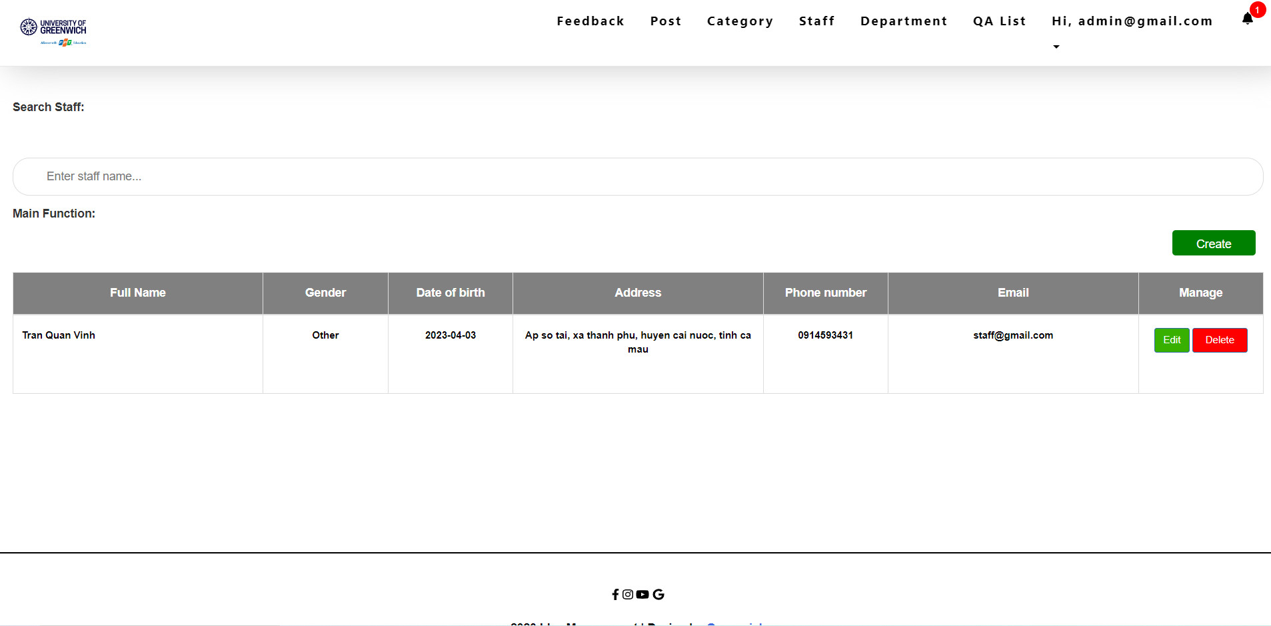

**Figure 33:** Staff interface

This is the Staff interface, which in this page belongs to the administrator's control. In this section, the administrator will perform tasks such as adding, editing, and deleting staff.

* **Add staff interface**

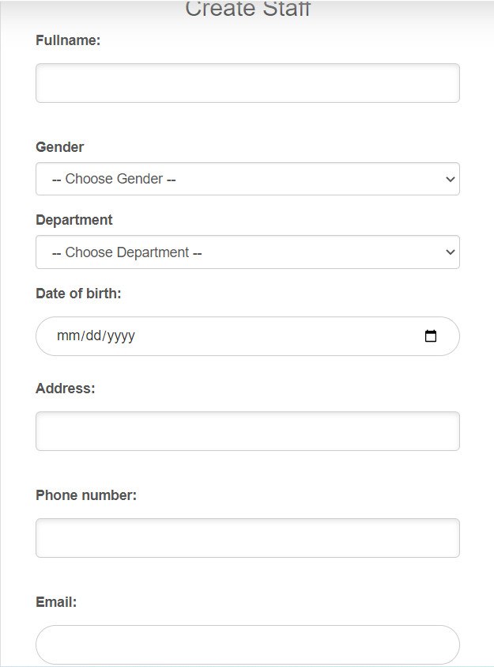

**Figure 34:** Add staff

This is the interface to add a new staff, in this page will display the necessary information to create a new staff

* **Edit staff interface**

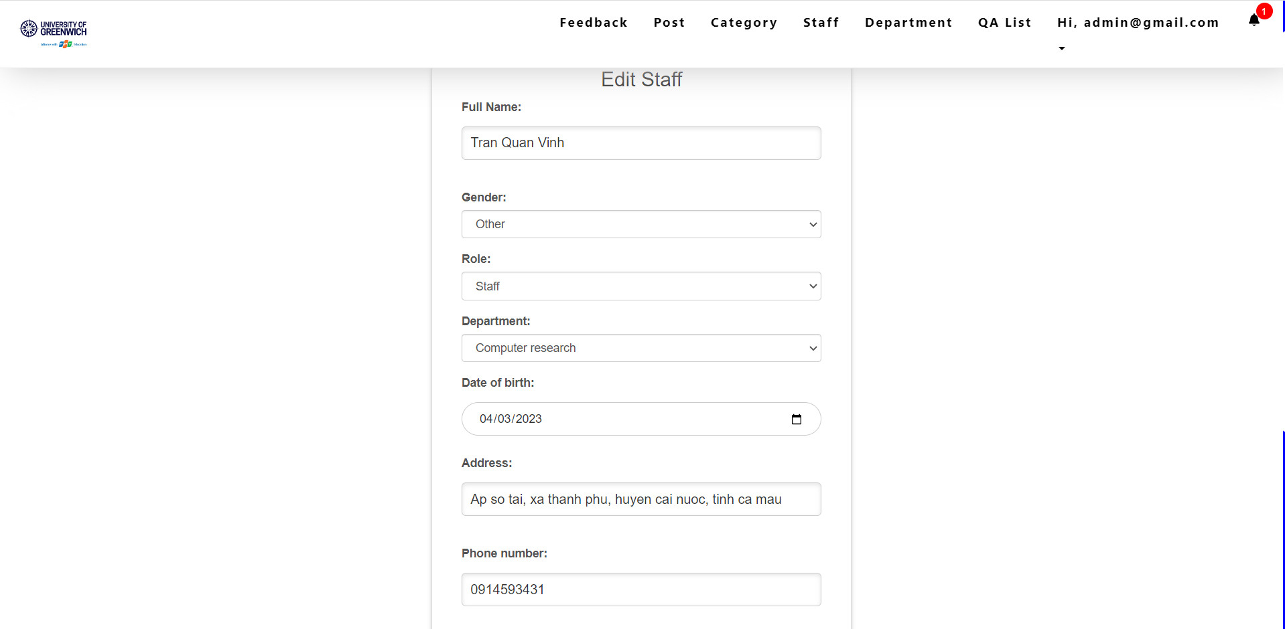

**Figure 35:** Edit staff interface

This is the staff editing interface, in this page will display the information of a post so that the admin wants to edit any information of that staff.

* **Delete staff interface**

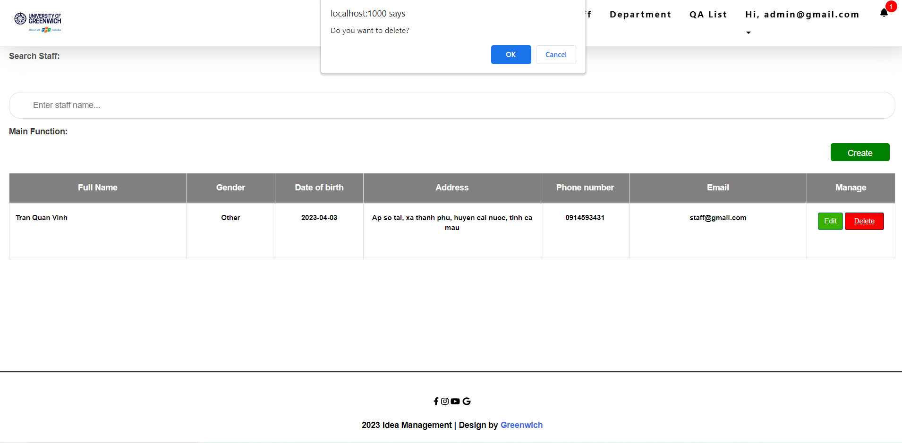

**Figure 36:** Delete staff interface

This is the interface to delete a staff, in this part the system will display a message to confirm that the administrator wants to really delete the staff or not. If you choose Ok, the system will delete it, if you choose Cancel, you will return to the Staff page

* **Department interface**

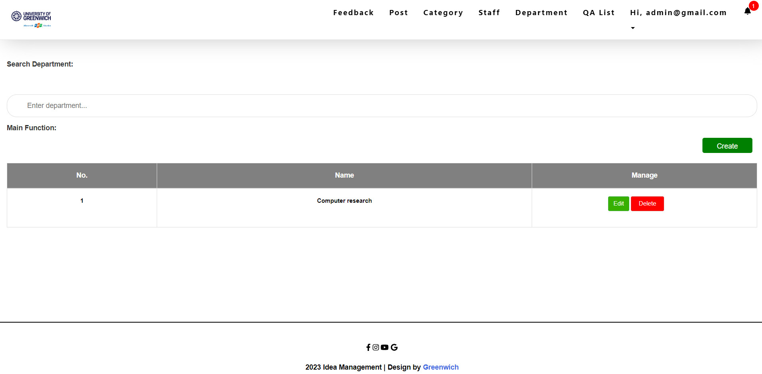

**Figure 37:** Department interface

This is the Department interface, which in this page belongs to the administrator's control. In this section, the administrator will perform tasks such as adding and deleting department.

* **Add department interface**

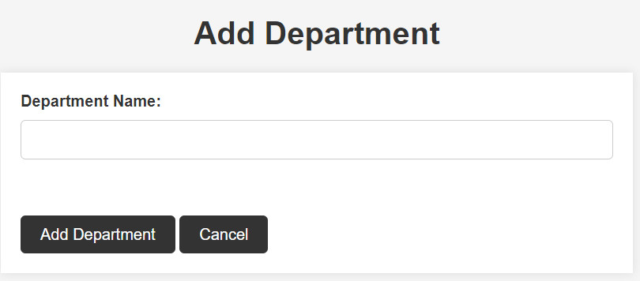

**Figure 38:** Add department

This is the interface to add a new department, in this page will display the necessary information to create a new department

* **Edit department interface**

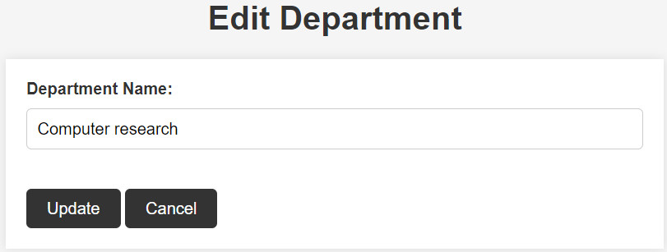

**Figure 39:** Edit department

This is the department editing interface, in this page will display the information of a department so that the admin wants to edit any information of that department.

* **Delete department interface**

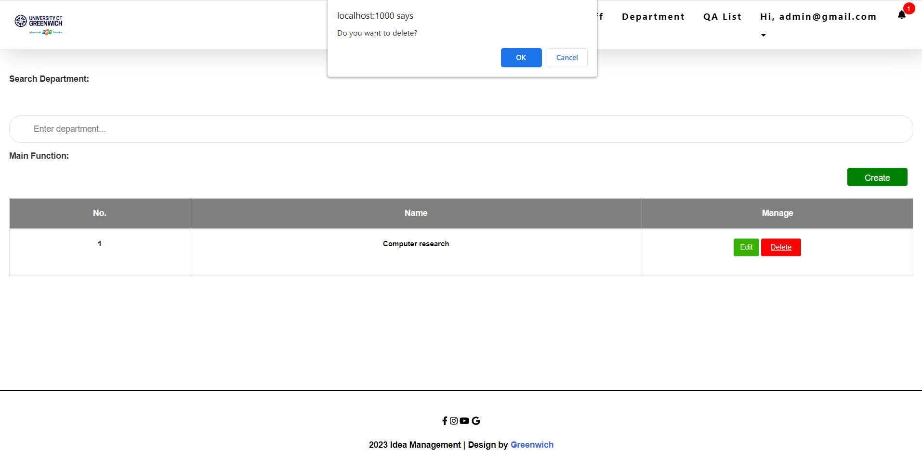

**Figure 40:** Delete department interface

This is the interface to delete a department, in this part the system will display a message to confirm that the administrator wants to really delete the department or not. If you choose Ok, the system will delete it, if you choose Cancel, you will return to the Department page

* **QA list interface**

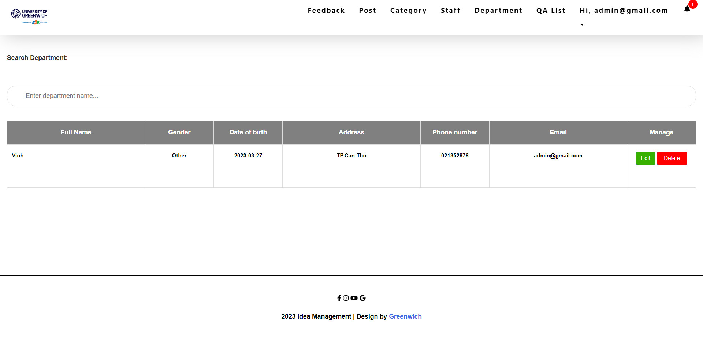

**Figure 41:** QA list interface

This is the QA list interface, which in this page belongs to the administrator's control. In this section, the administrator will perform tasks such as editing, and deleting account.

* **Update profile interface**

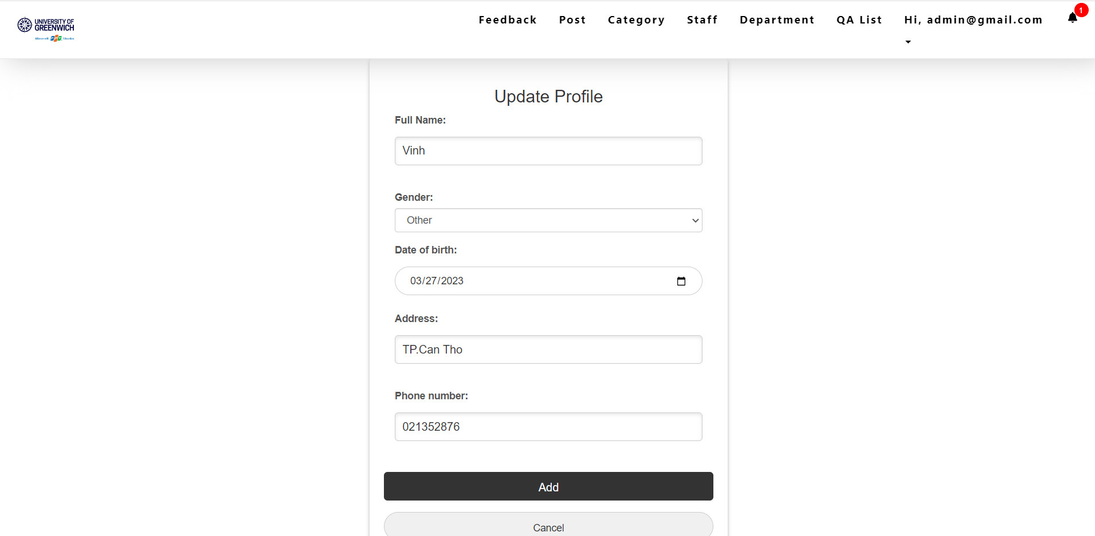

**Figure 42:** Update profile interface

This is the update profile interface, in this page will display the information of account so that the user can edit any information of that account.

* **Change password interface**

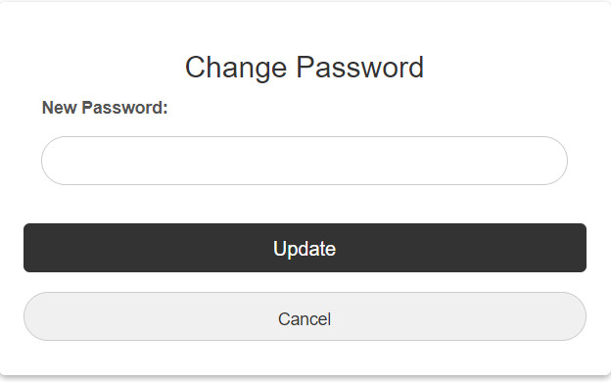

**Figure 43:** Change password interface

This is the change password of user account interface, in this page will display password of a account so that the user wants to change password of that account.

* **Interface when logged in with staff account**

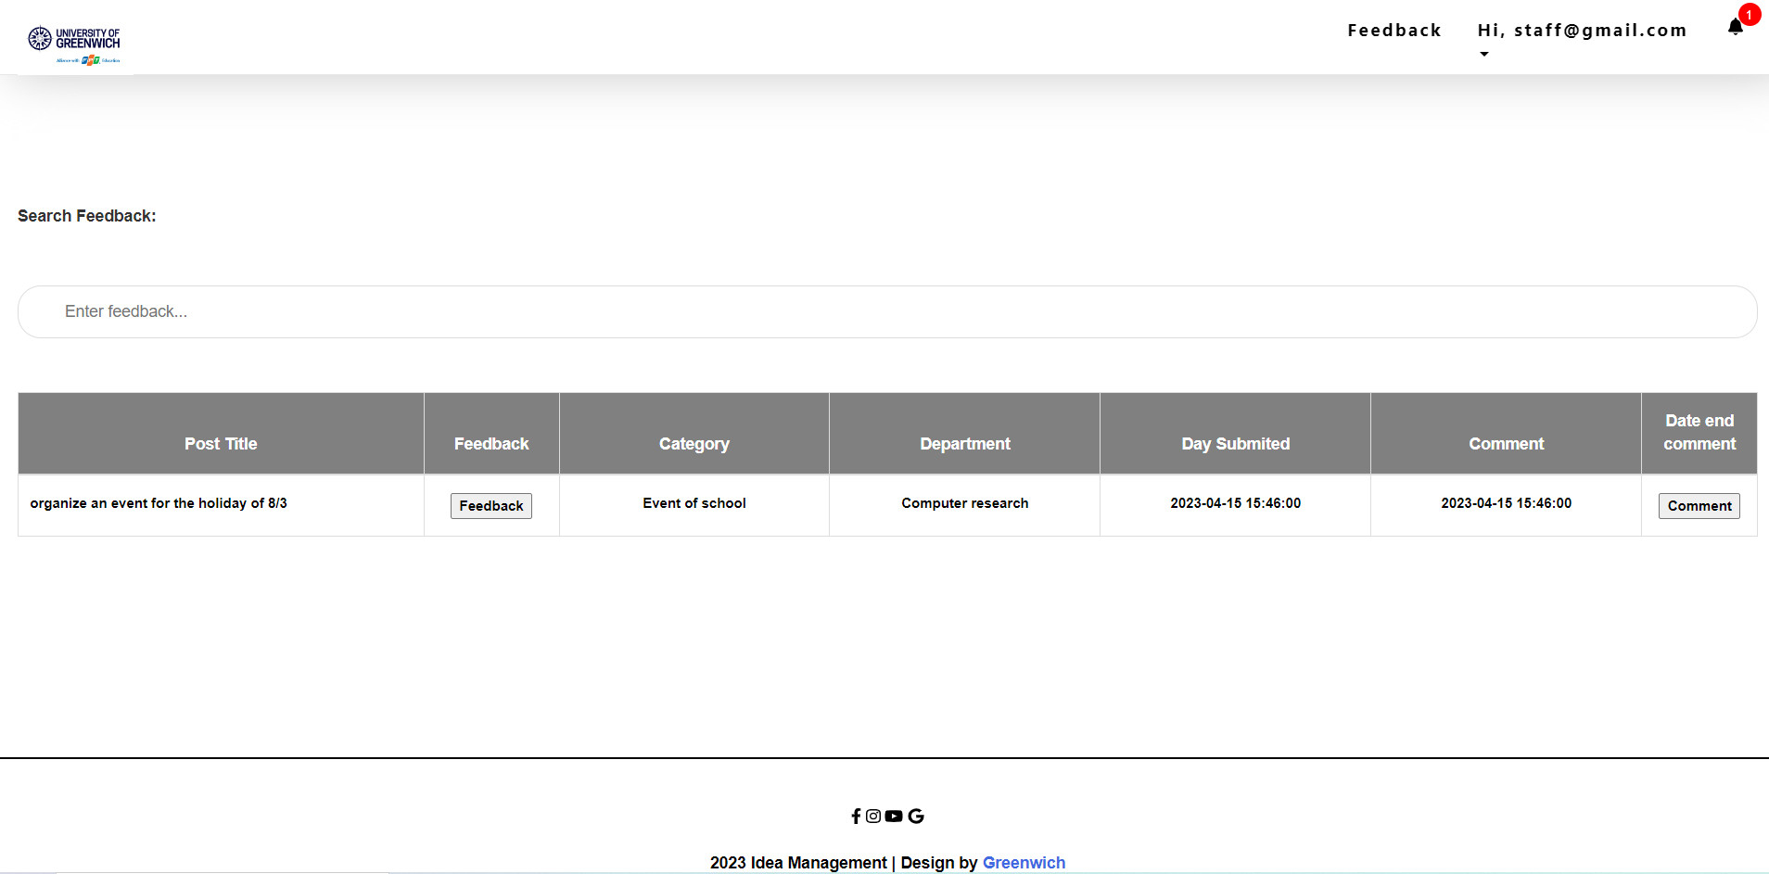

**Figure 44:** Interface when logged in with staff account

This is the interface after the user has successfully logged into the system, here is the staff account

* **View post and feedback interface**

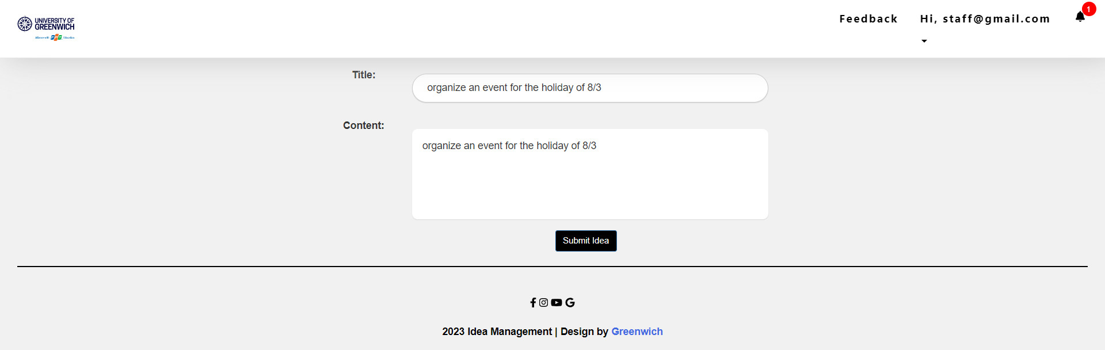

**Figure 45:** View post and feedback interface

This is the interface after the user clicks the Feedback button.

* **Submit idea interface**

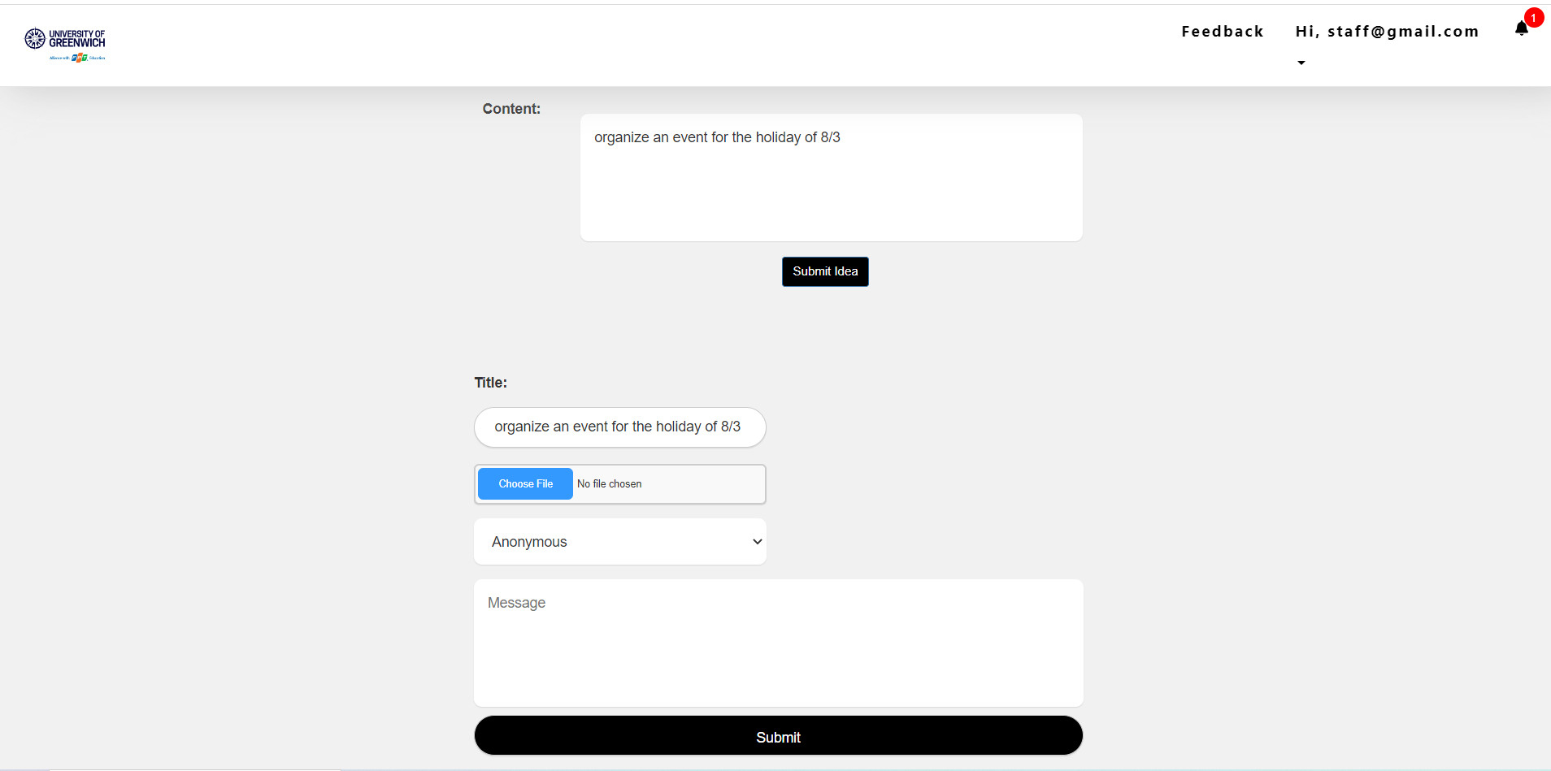

**Figure 46:** Submit idea interface

This is the interface after the user clicks on the Submit idea button.

* **List feedback interface**

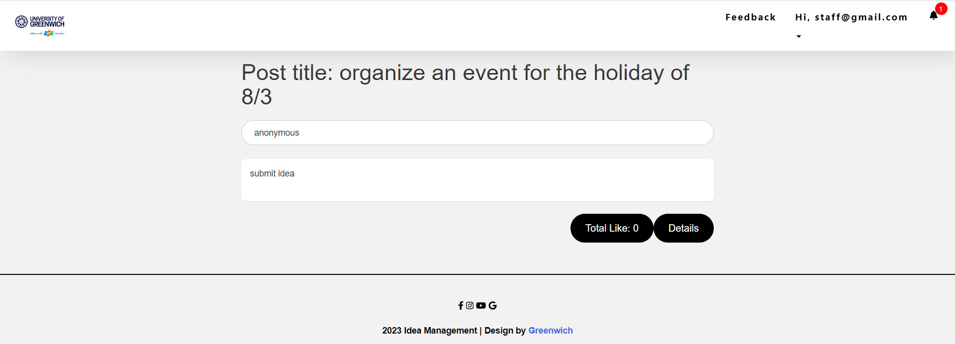

**Figure 47:** List feedback interface

Here is the following interface showing the list of responses.

* **Comment and like interface**

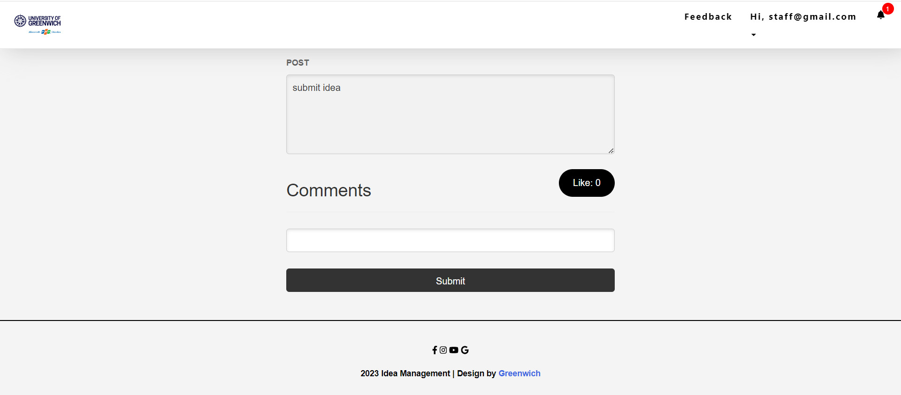

**Figure 48:** Comment and like interface

This is a command and like interface, this interface you will use to enter comment information in the empty boxes and click Submit to save the comment information or click like button to like this idea.

# **Functionality**

## **Use case diagram**

### **Admin**

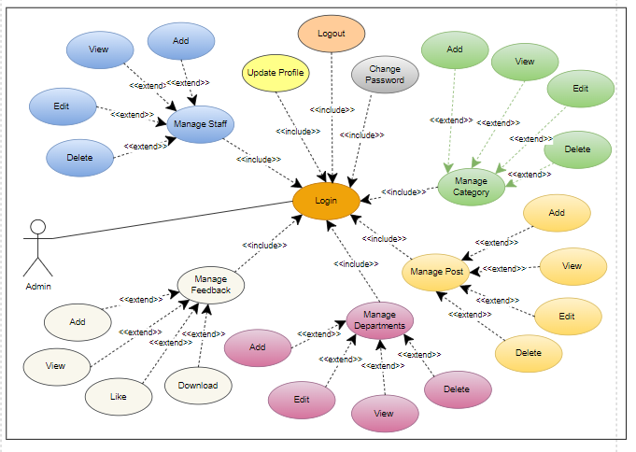

**Figure 49:** Usecase diagram (Admin)

**Explain:** In the Use case diagram Admin, users will be provided with many functions to manage and control the entire system of the website. When accessing the login section, users can use their account and password to log in to the system.

If the login information is correct, the system will move to the Manage Staff section to allow the user to perform staff management related tasks. Inside this section, users will have the functions of adding, editing, deleting, viewing to easily manage information about employees working in the company

Besides, the Manage Department section is designed to manage departments in the company. Users will also have functions to add, edit, delete, view to manage information about departments. These functions will help users manage the most easily and accurately.

The Manage Categories section is designed to manage the categories used in the website. Users will have the functions of adding, editing, deleting, viewing to be able to manage information about that category. This will make the management and classification of information on the website easier than ever

The Manage Post section will help users manage articles on the website. Users will have the functions of adding, editing, deleting, viewing to easily manage and display better articles on the website.

Besides, about the profile, users can perform the functions of updating personal information, changing passwords, and logging out. This helps users to keep their personal information safe and secure.

### **Staff**

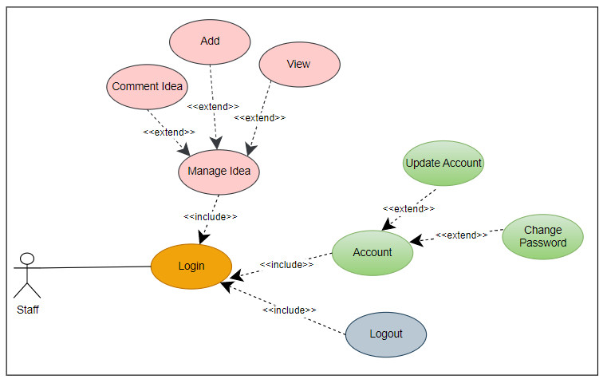

**Figure 50:** Usecase diagram (Staff)

**Explain:** In the Use case diagram Staff, users will be provided with a comment management section with many functions so that users can perform tasks related to comments and feedback from customers. In the comment management section, Staff will be provided with the functions of adding, viewing and writing comments to easily manage and display the comment information. Besides, Staff can also track and respond to customer feedback quickly and conveniently. In addition, the profile management section allows users to update personal information, change passwords. Employees can update their personal information to keep it safe and secure. Changing the password allows users to enhance the security of their accounts on the system.

## **Activity diagram**

### **Admin**

* **Update Account**

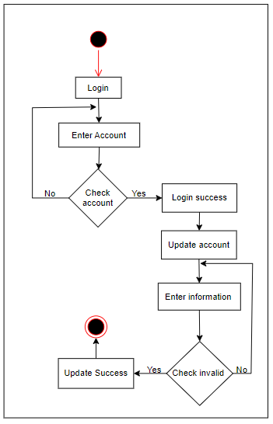

**Figure 51:** Update account activity

Start admin need to log in, admin needs to enter his account information, then the system will check if the account is correct or not, if it's wrong, the system will let admin re-enter the information, if it's correct, it will access the administrator's management system. Next, the admin needs to choose to update the account, enter the information to be edited, at this time the system will check the admin information just entered the system, if ok, the admin's information account will be updated, if not, the system will update. The system will not update and let the admin re-enter the information.

* **Change Password**

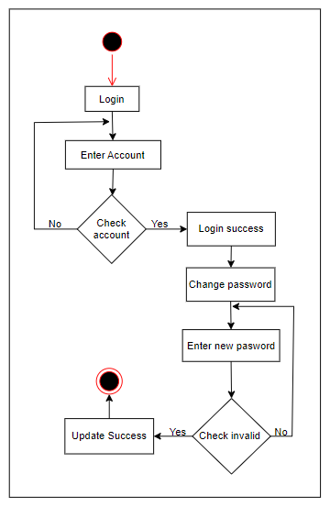

**Figure 52:** Change password activity

Start admin need to log in, admin needs to enter his account information, then the system will check if the account is correct or not, if it's wrong, the system will let admin re-enter the information, if it's correct, it will access the administrator's management system. Next admin needs to change his password, next will be to enter a new password, this time the system will check that admin's password will be updated, otherwise the system will not update and let admin re-enter information

* **Add Department**

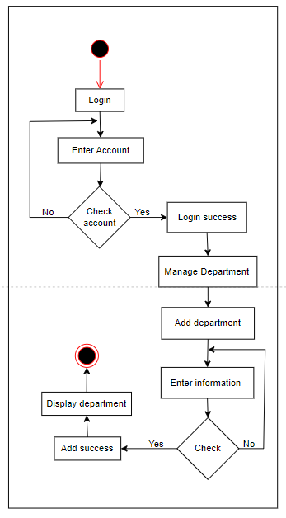

**Figure 53:** Add department activity

Start admin need to log in, admin needs to enter his account information, then the system will check if the account is correct or not, if it's wrong, the system will let admin re-enter the information, if it's correct, it will access the administrator's management system. Next, the administrator needs to manage the Department of the system. In this section, the administrator wants to add a new department, then choose to add new, then enter the department information into the system and add it, now the system will check if the department's information is correct, it will add the information to the database. data, message display and department display have just been added.

* **Edit Department**

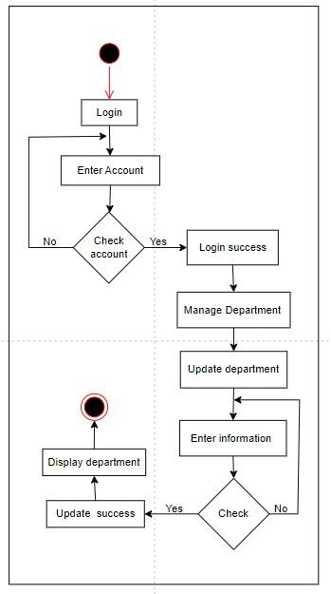

**Figure 54:** Edit department activity

Start admin need to log in, admin needs to enter his account information, then the system will check if the account is correct or not, if it's wrong, the system will let admin re-enter the information, if it's correct, it will access the administrator's management system. Next, the administrator needs to manage the Department of the system. In this section, the administrator wants to edit a department, the administrator selects that department. Next will be to enter the information you need to edit and update it, this time the system will check if the department information has just been properly edited, it will be updated. The data will be updated in the database. Whether. then will display the department that has just been edited. If the system does not check properly, the administrator will re-enter the department information and not update the data.

* **Delete Department**

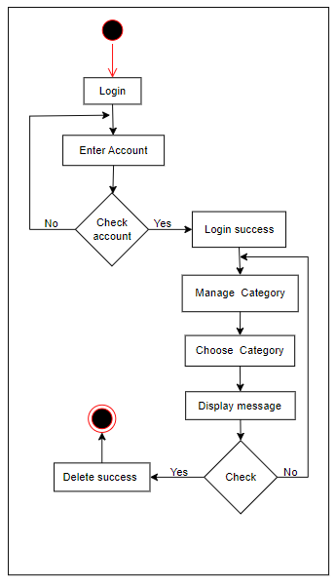

**Figure 55:** Delete department activity

Start admin need to log in, admin needs to enter his account information, then the system will check if the account is correct or not, if it's wrong, the system will let admin re-enter the information, if it's correct, it will access the administrator's management system. Next, the administrator needs to manage the Department of the system. In this section, the administrator wants to delete a department, the administrator selects that department. Then the system will display a message to make sure the administrator wants to delete it or not. If yes is selected, the system will check and delete that department information from the database, if not, the system will return to the department management page.

* **Add Post**

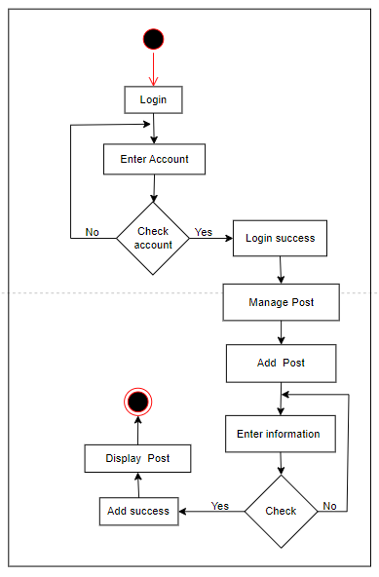

**Figure 56:** Add post activity

Start admin need to log in, admin needs to enter his account information, then the system will check if the account is correct or not, if it's wrong, the system will let admin re-enter the information, if it's correct, it will access the administrator's management system. Next, the administrator needs to manage the Post of the system. In this section, the administrator wants to add a new post, then choose to add new, then enter the post information into the system and add it, now the system will check if the post information is correct, it will add the information to the database. data, message display and post display have just been added.

* **Edit Post**

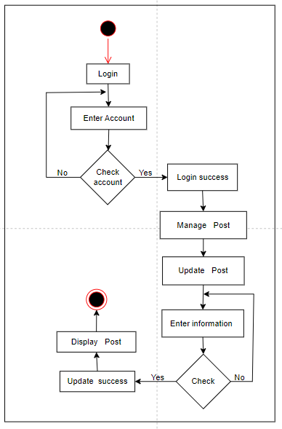

**Figure 57:** Edit post activity

Start admin need to log in, admin needs to enter his account information, then the system will check if the account is correct or not, if it's wrong, the system will let admin re-enter the information, if it's correct, it will access the administrator's management system. Next, the administrator needs to manage the post of the system. In this section, the administrator wants to edit a post, the administrator selects that post. Next will be to enter the information you need to edit and update it, this time the system will check if the post information has just been properly edited, it will be updated. The data will be updated in the database. Whether. then will display the post that has just been edited. If the system does not check properly, the administrator will re-enter the post information and not update the data.

* **Delete Post**

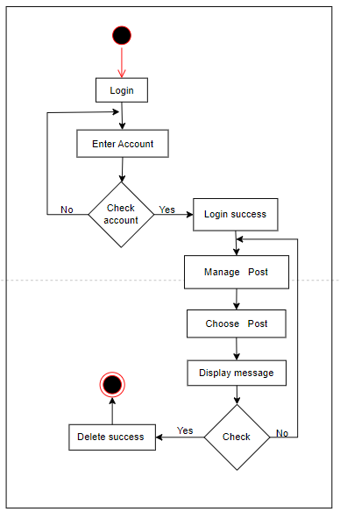

**Figure 58:** Delete post

Start admin need to log in, admin needs to enter his account information, then the system will check if the account is correct or not, if it's wrong, the system will let admin re-enter the information, if it's correct, it will access the administrator's management system. Next, the administrator needs to manage the post of the system. In this section, the administrator wants to delete post, the administrator selects that post. Then the system will display a message to make sure the administrator wants to delete it or not. If Yes is selected, the system will check and delete that post information from the database, if not, the system will return to the post management page.

* **Add category**

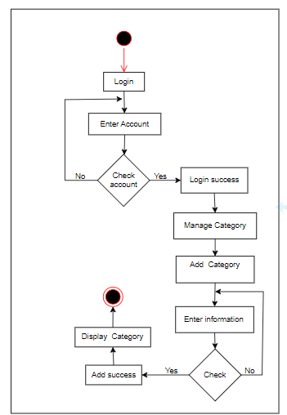

**Figure 59:** Add category activity

Start admin need to log in, admin needs to enter his account information, then the system will check if the account is correct or not, if it's wrong, the system will let admin re-enter the information, if it's correct, it will access the management system. manager's management. Next, the administrator needs to manage the category of the system. In this section, the administrator wants to add a new category, then select add new and then enter category information into the system and add, at this time the system will check if the category information is correct, then add the information. database. data, message display, and part display have just been added.

* **Edit category**

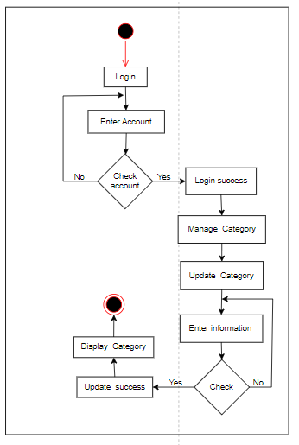

**Figure 60:** Edit category activity

Start admin need to log in, admin needs to enter his account information, then the system will check if the account is correct or not, if it's wrong, the system will let admin re-enter the information, if it's correct, it will access the administrator's management system. Next, the administrator needs to manage the category of the system. In this section, the administrator wants to edit a category, the administrator selects that department. Next will be to enter the information you need to edit and update it, this time the system will check if the category information has just been properly edited, it will be updated. The data will be updated in the database. Whether. then will display the category that has just been edited. If the system does not check properly, the administrator will re-enter the category information and not update the data.

* **Delete category**

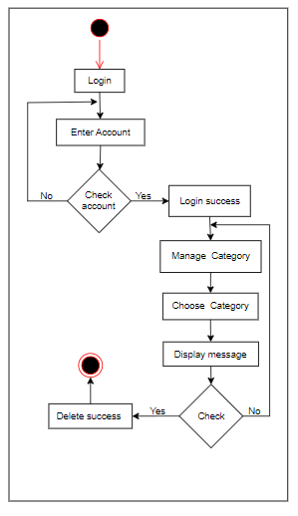

**Figure 61:** Delete category activity

Start admin need to log in, admin needs to enter his account information, then the system will check if the account is correct or not, if it's wrong, the system will let admin re-enter the information, if it's correct, it will access the administrator's management system. Next, the administrator needs to manage the category of the system. In this section, the administrator wants to delete a category, the administrator selects that category. Then the system will display a message to make sure the administrator wants to delete it or not. If Yes is selected, the system will check and delete that category information from the database, if not, the system will return to the category management page.

* **Add staff**

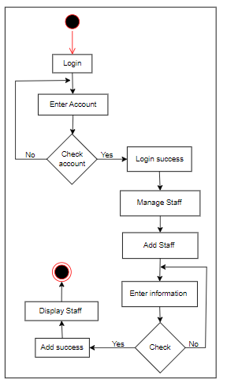

**Figure 62:** Add staff activity

Start admin need to log in, admin needs to enter his account information, then the system will check if the account is correct or not, if it's wrong, the system will let admin re-enter the information, if it's correct, it will access the management system. manager's management. Next, the administrator needs to manage the staff of the system. In this section, the administrator wants to add a new staff, then select add new and then enter the staff. Information into the system and add, at this time the system will check if the staff information is correct, then add the information. database. data, message display, and part display have just been added.

* **Edit staff**

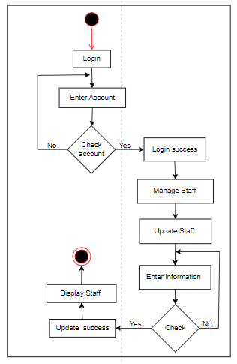

**Figure 63:** Edit staff activity

Start admin need to log in, admin needs to enter his account information, then the system will check if the account is correct or not, if it's wrong, the system will let admin re-enter the information, if it's correct, it will access the administrator's management system. Next, the administrator needs to manage the staff of the system. In this section, the administrator wants to edit a staff, the administrator selects that staff. Next will be to enter the information you need to edit and update it, this time the system will check if the staff information has just been properly edited, it will be updated. The data will be updated in the database. Whether. then will display the staff that has just been edited. If the system does not check properly, the administrator will re-enter the staff information and not update the data.

* **Delete staff**

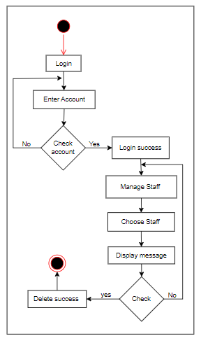

**Figure 64:** Delete staff activity

Start admin need to log in, admin needs to enter his account information, then the system will check if the account is correct or not, if it's wrong, the system will let admin re-enter the information, if it's correct, it will access the administrator's management system. Next, the administrator needs to manage the staff of the system. In this section, the administrator wants to delete a staff, the administrator selects that staff. Then the system will display a message to make sure the administrator wants to delete it or not. If yes is selected, the system will check and delete that staff information from the database, if not, the system will return to the staff management page.

* **Writing feedback**

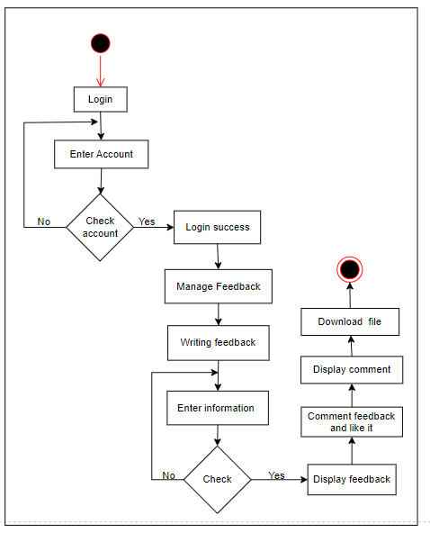

**Figure 65:** Writing feedback

Start admin need to log in, admin needs to enter his account information, then the system will check if the account is correct or not, if it's wrong, the system will let admin re-enter the information, if it's correct, it will access the management system. manager's management. Next, the administrator will go to Manage Feedback and create new feedback. The administrator needs to enter the information of the feedback, now the system will check if the information is not valid, the system will let the manager re-enter the information of the feedback, if it is reasonable, the system will display the feedback and the data will be saved in the database, next the administrator will drop a like for the response and comment on that response. Then the system will display all comments and will download the file if the administrator wants.

### **Staff**

* **Update Account**



**Figure 66:** Update account activity

Start staff need to log in, staff needs to enter his account information, then the system will check if the account is correct or not, if it's wrong, the system will let staff re-enter the information, if it's correct, it will access the staff management system. Next, the staff needs to choose to update the account, enter the information to be edited, at this time the system will check the staff information just entered the system, if ok, the admin's information account will be updated, if not, the system will update. The system will not update and let the staff re-enter the information.

* **Change Password**



**Figure 67:** Change password

Start staff need to log in, staff needs to enter his account information, then the system will check if the account is correct or not, if it's wrong, the system will let staff re-enter the information, if it's correct, it will access staff management system. Next staff needs to change his password, next will be to enter a new password, this time the system will check that admin's password will be updated, otherwise the system will not update and let staff re-enter information.

* **Add Idea**

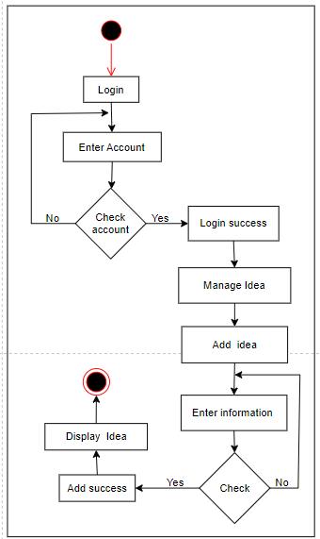

**Figure 68:** Add idea

Start staff need to log in, staff needs to enter his account information, then the system will check if the account is correct or not, if it's wrong, the system will let staff re-enter the information, if it's correct, it will access a staff management system. Next, the staff needs to manage the idea of the system. In this section, the staff wants to add a new idea, then choose to add new, then enter the idea information into the system and add it, now the system will check if the idea information is correct, it will add the information to the database. data, message display and idea display have just been added.

* **Edit idea**

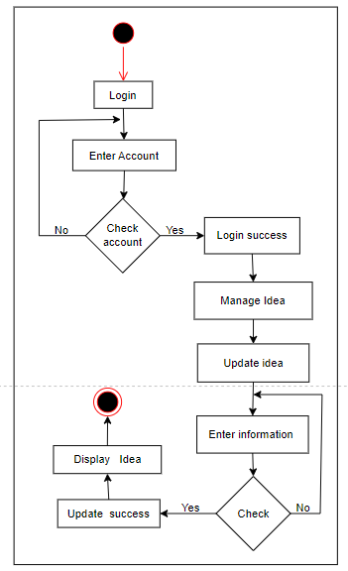

**Figure 69:** Edit idea

Start staff need to log in, staff needs to enter his account information, then the system will check if the account is correct or not, if it's wrong, the system will let staff re-enter the information, if it's correct, it will access the staff management system. Next, the staff needs to manage the idea of the system. In this section, the staff wants to edit idea, the staff selects that idea. Next will be to enter the information you need to edit and update it, this time the system will check if the idea information has just been properly edited, it will be updated. The data will be updated in the database. Whether. then will display the idea that has just been edited. If the system does not check properly, the staff will re-enter the idea information and not update the data.

* **Delete Idea**

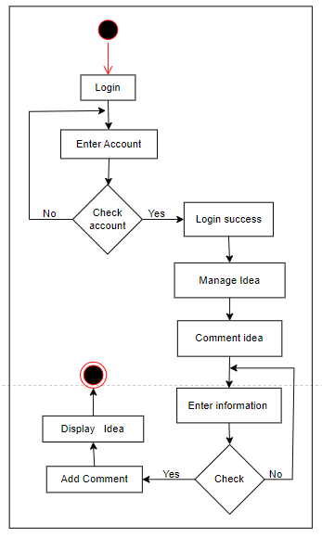

**Figure 70:** Delete idea

Start staff need to log in, staff needs to enter his account information, then the system will check if the account is correct or not, if it's wrong, the system will let staff re-enter the information, if it's correct, it will access the staff management system. Next, the staff needs to manage the idea of the system. In this section, the staff wants to delete idea, the staff selects that idea. Then the system will display a message to make sure the staff wants to delete it or not. If Yes is selected, the system will check and delete that idea information from the database, if not, the system will return to the idea management page.

## **Demo function**

* **Login interface**

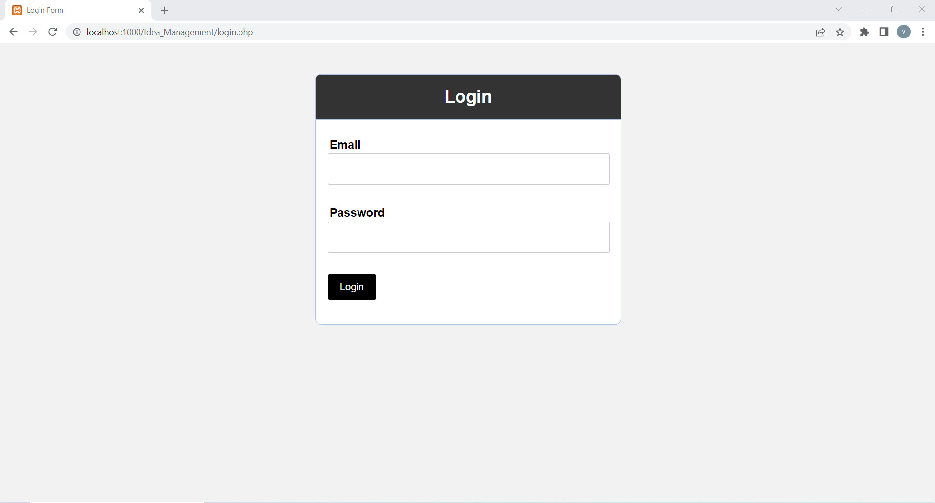

**Figure 71:** Login interface

**Explain:** This is login interface, in this page user can login with an existing account

* **Login with account**

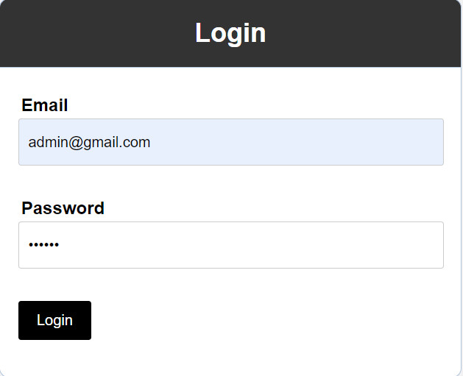

**Figure 72:** Login with admin account

**Explain:** User can login to admin interface with admin account

* **After login with admin account**

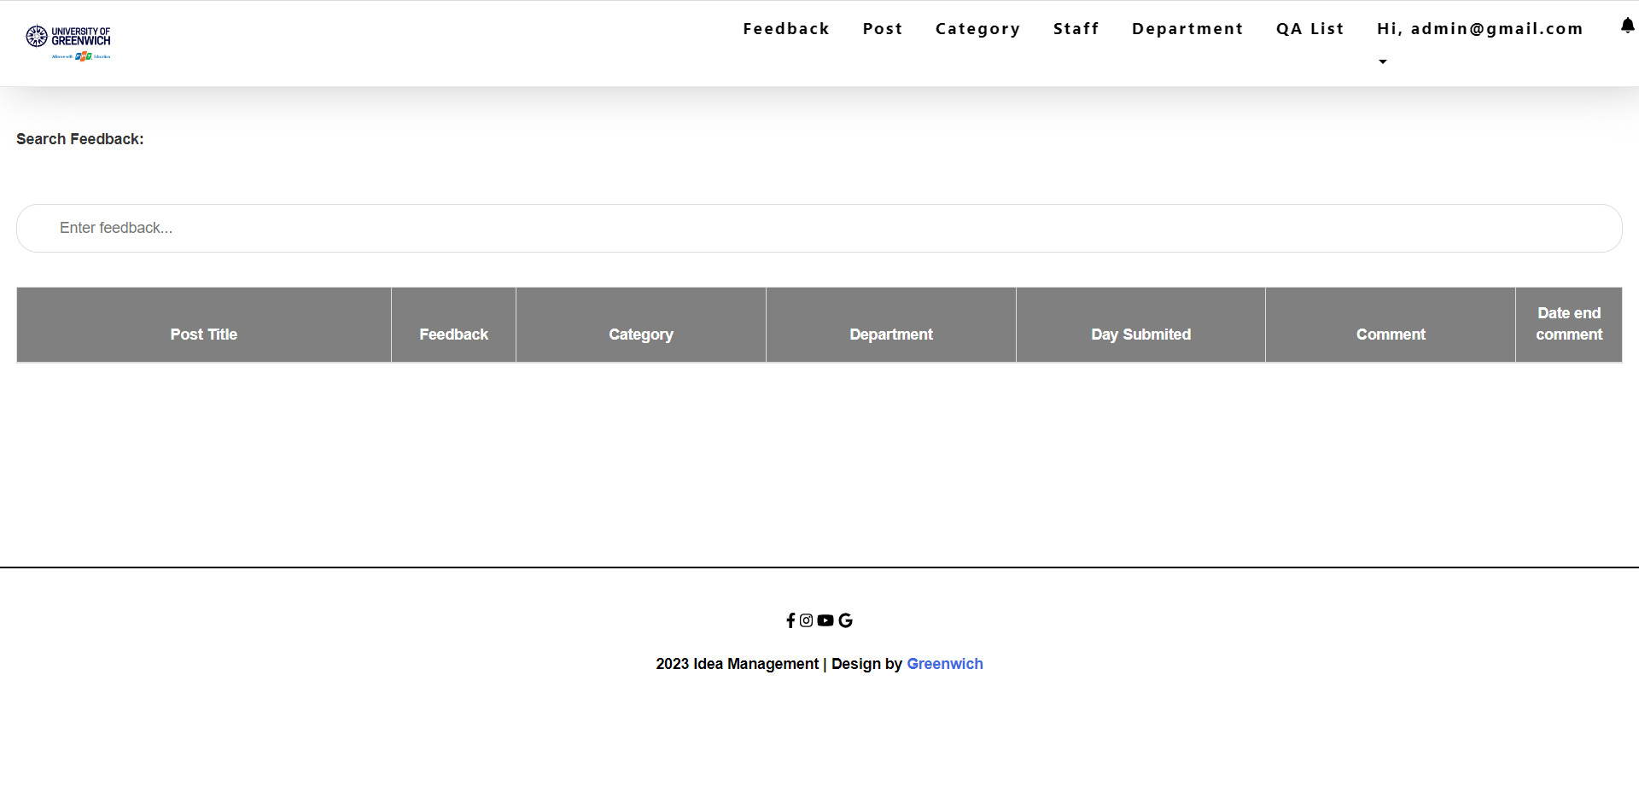

**Figure 73:** After login with admin account

**Explain:** This is the interface after login with admin account and this is also an interface that displays information for staff so that staff can give feedback such as post title, category, department, day submitted and date end comment, admin can click on pages like post, category, staff, department, QA List to view or manage them.

* **Category interface**

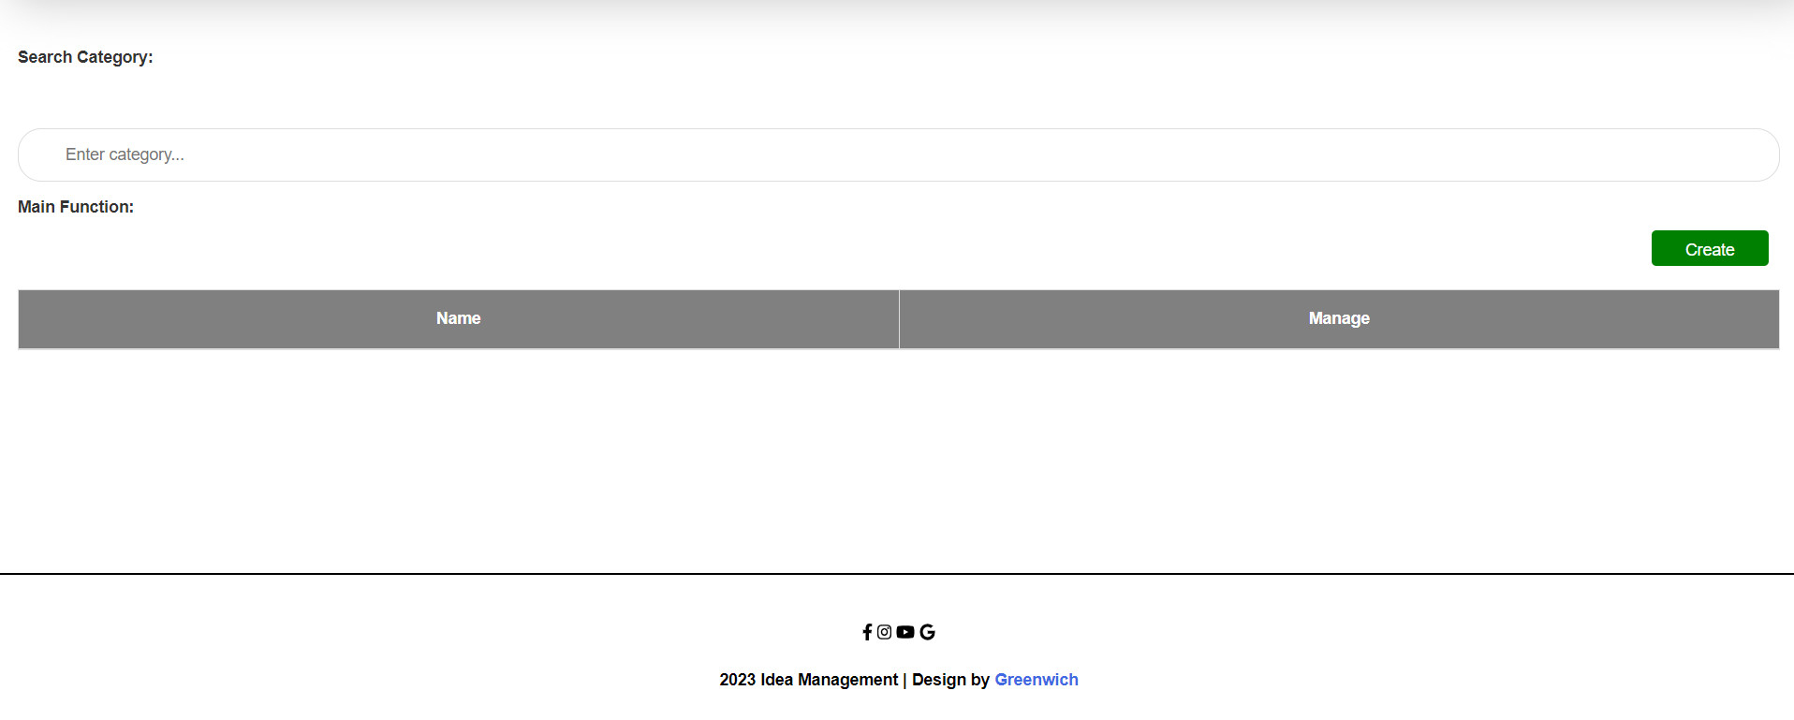

**Figure 74:** Category interface

**Explain:** This is the category interface, where admin can create category and manage them like edit and delete.

* **Add category**

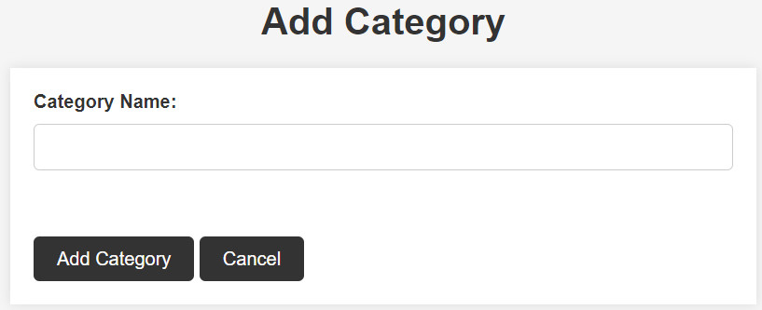

**Figure 75:** Add category

**Explain:** This is the "Add Category" interface after the admin presses the create button in the post interface. Here admin can fill in the post's information and press the "Add Category" button to create a new category.

* **Add category information**

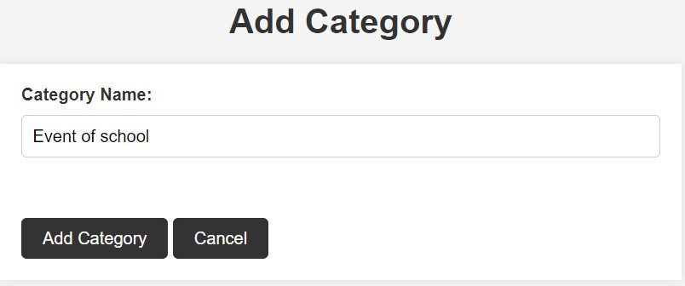

**Figure 76:** Add category information

**Explain:** This is what it looks like after I add information to the category.

* **Show category information**

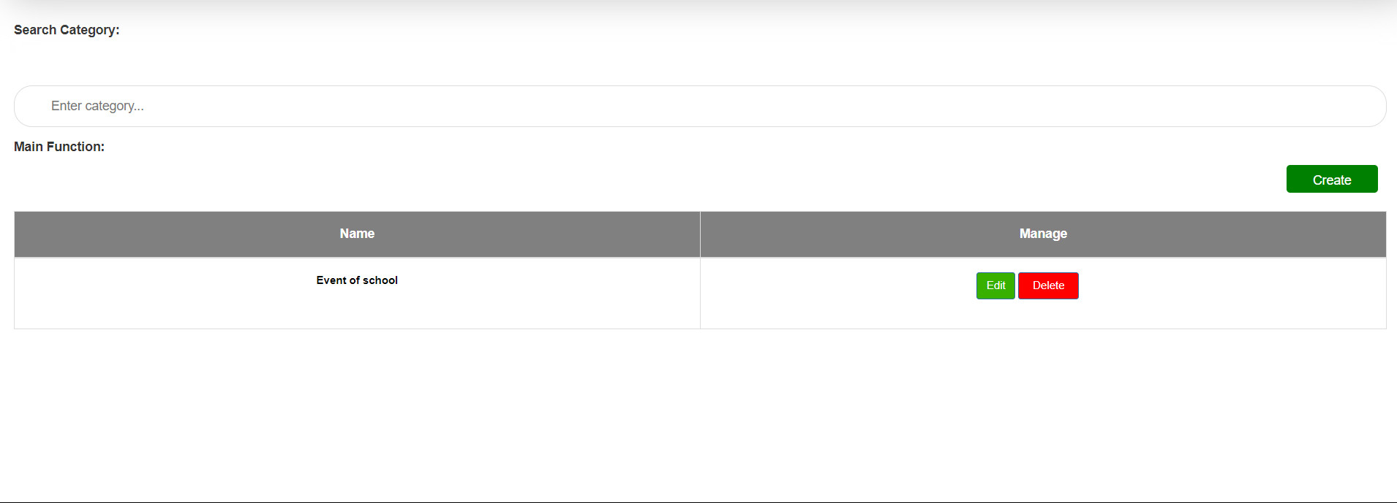

**Figure 77:** Show category information

**Explain:** After filling in the category information, press the "Category" button on the "Create Category" page. Category information will be displayed here.

* **Delete category**

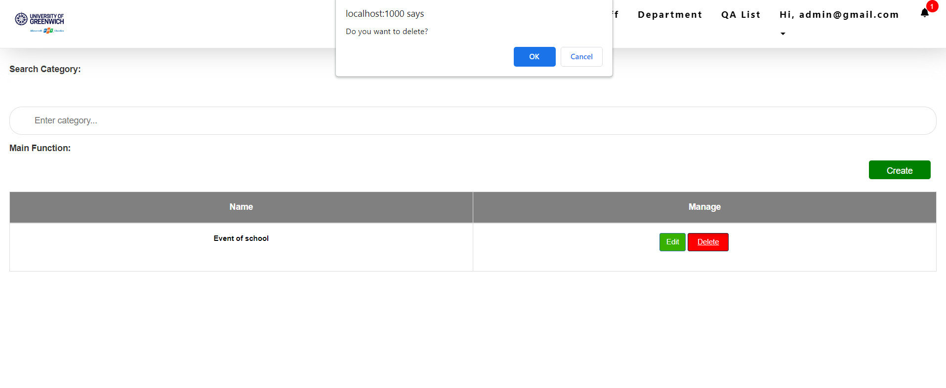

**Figure 78:** Delete category

**Explain:** After pressing the delete button in the interface, the message line "Do you want to delete?". Users can choose "yes" to delete the category or select "no" to cancel.

* **Department interface**

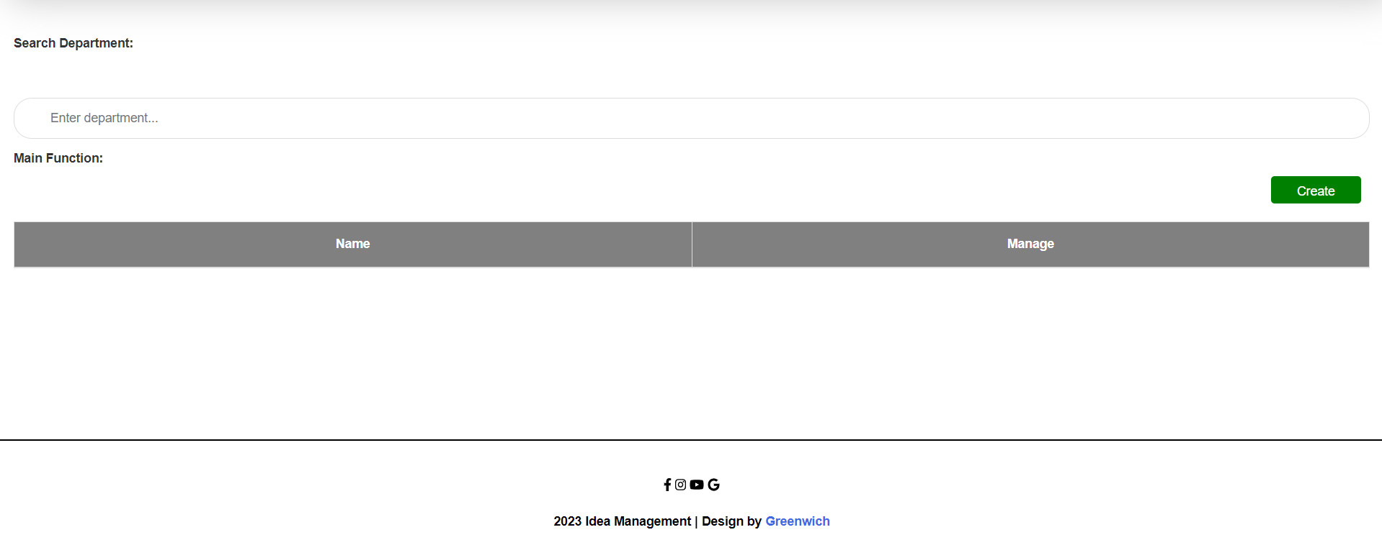

**Figure 79:** Department interface

**Explain:** This is the department interface, where admin can create department and manage them like edit and delete.

* **Create department interface**

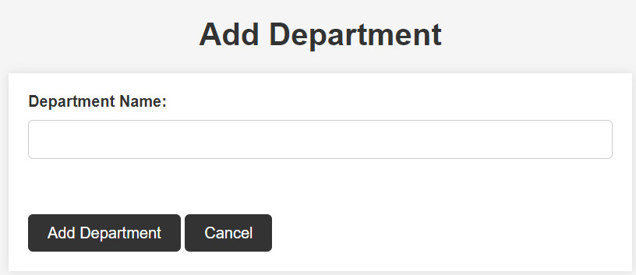

**Figure 80:** Create department interface

**Explain:** This is the "Create Department" interface after the admin presses the “create” button in the category interface. Here admin can fill in the category’s information and press the "Add Department" button to create a new category.

* **Add department information**

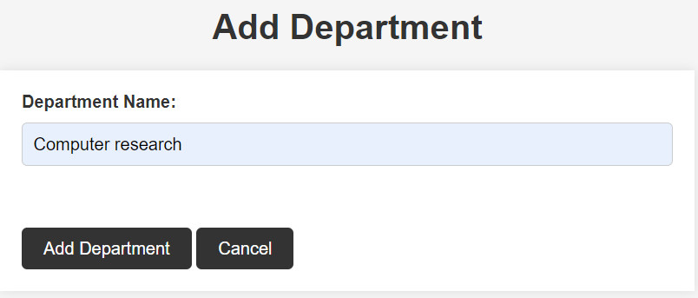

**Figure 81**: Add department information

**Explain:** This is what it looks like after I add information to the department.

* **Show department information**

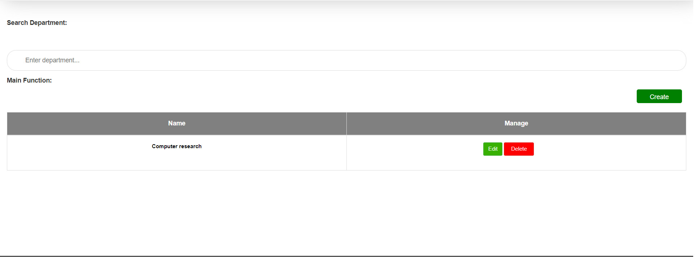

**Figure 82:** Show department information

**Explain:** After filling in the post information, press the "Add Department" button on the "Add Department" page. Department information will be displayed here.

* **Edit department**

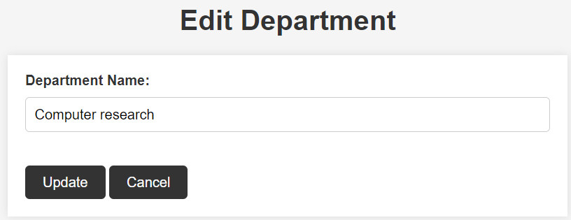

**Figure 83:** Edit department

**Explain:** This is the department edit interface, in this interface admin can change the department’s information.

* **Delete department**

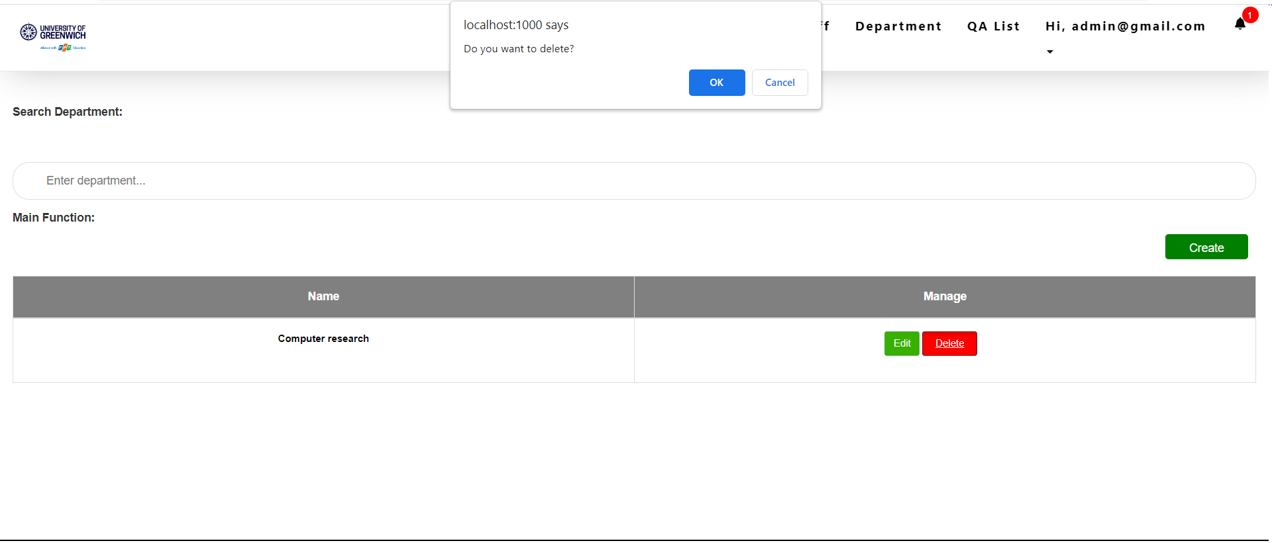

**Figure 84:** Delete department

**Explain:** After pressing the delete button in the interface, the message line "Do you want to delete?". Users can choose "yes" to delete the department or select "no" to cancel.

* **Staff interface**

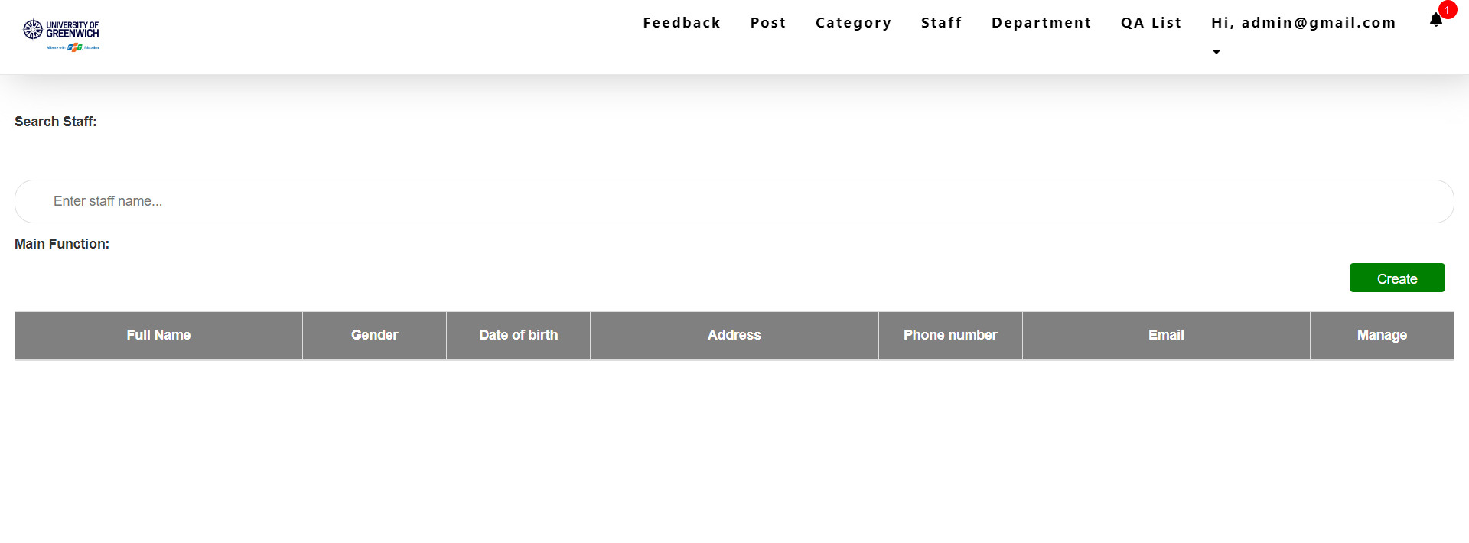

**Figure 85:** Staff interface

**Explain:** This is the staff interface, where admin can create staff and manage them like edit and delete

* **Create staff interface**

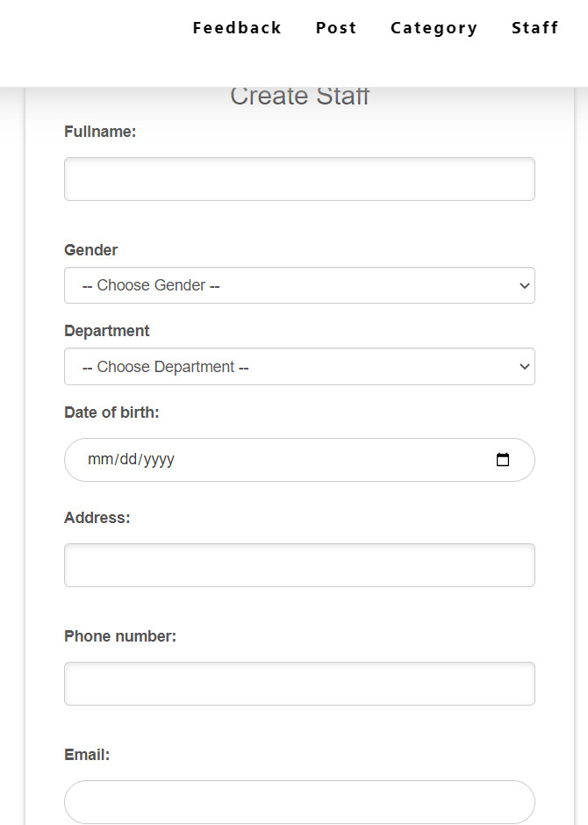

**Figure 86:** Create staff interface

**Explain:** This is the "Create staff" interface after the admin presses the create button in the staff interface. Here admin can fill in the staff’s information and press the "Add" button to create a new staff.

* **Create staff information**

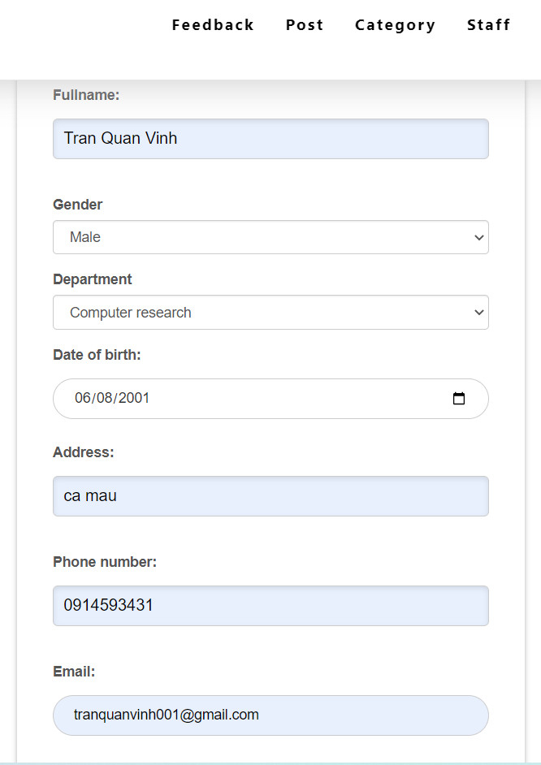

**Figure 87:** Create staff information

**Explain:** This is what it looks like after I add information to the staff.

* **Show staff information**

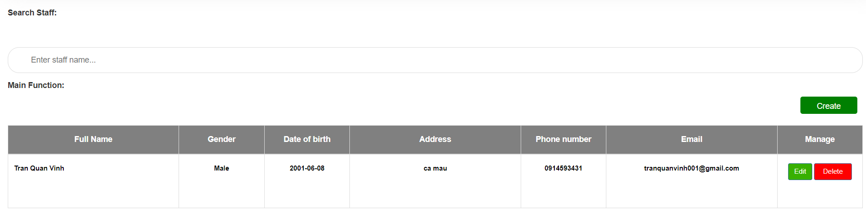

**Figure 88:** Show staff information

**Explain:** After filling in the staff information, press the "Add" button on the "Create Staff" page. Staff information will be displayed here.

* **Edit staff**

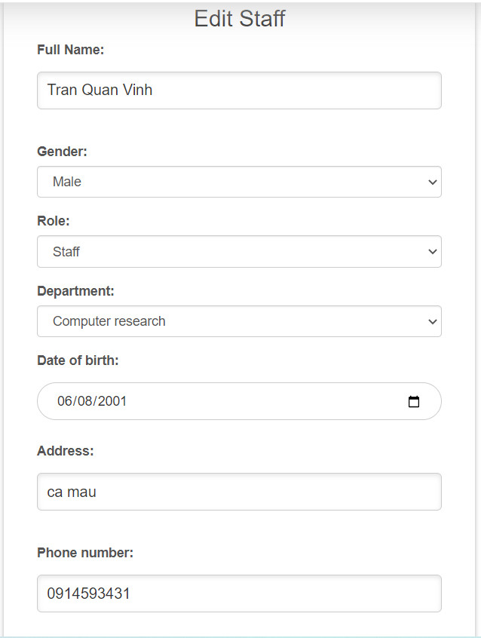

**Figure 89:** Edit Staff

**Explain:** This is the staff edit interface, in this interface admin can change the staff’s information.

* **After edit staff**

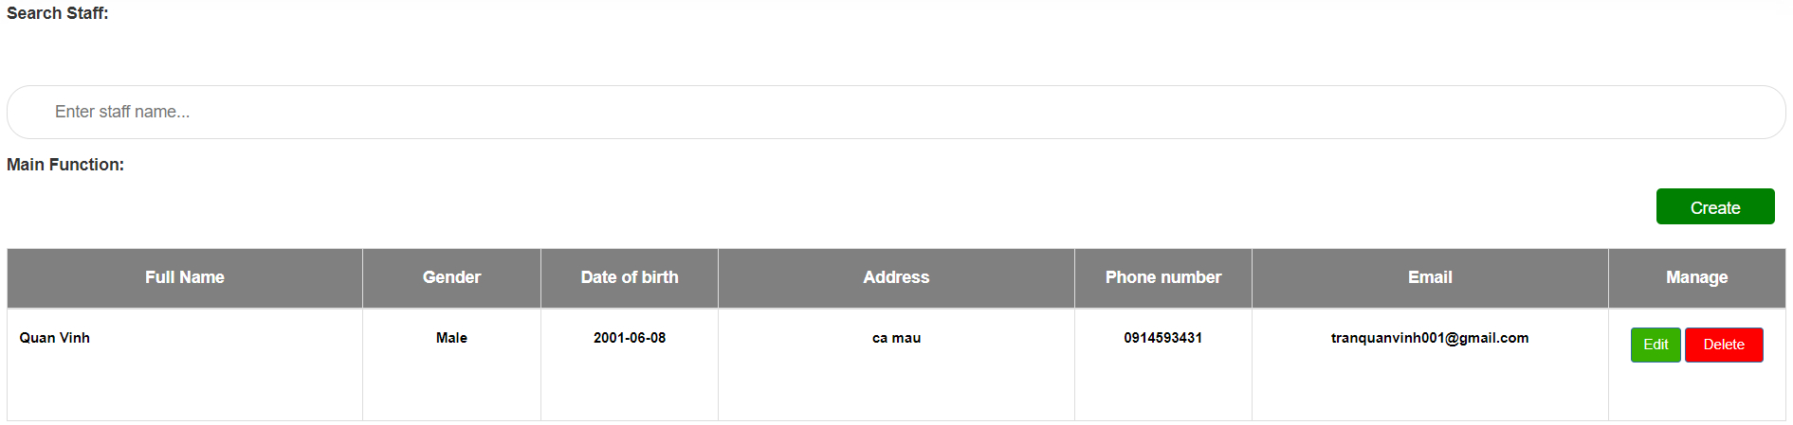

**Figure 90:** After edit staff

**Explain:** This is the interface after changing the fullname information of the staff.

* **Delete staff**

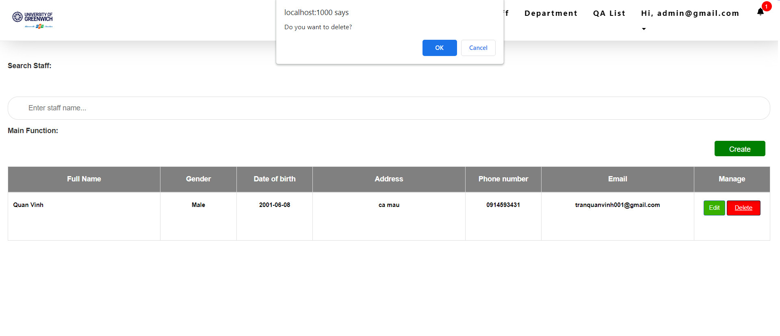

**Figure 91:** Delete staff

**Explain:** After pressing the delete button in the interface, the message line "Do you want to delete?". Users can choose "yes" to delete the staff or select "no" to cancel.

* **Post interface**

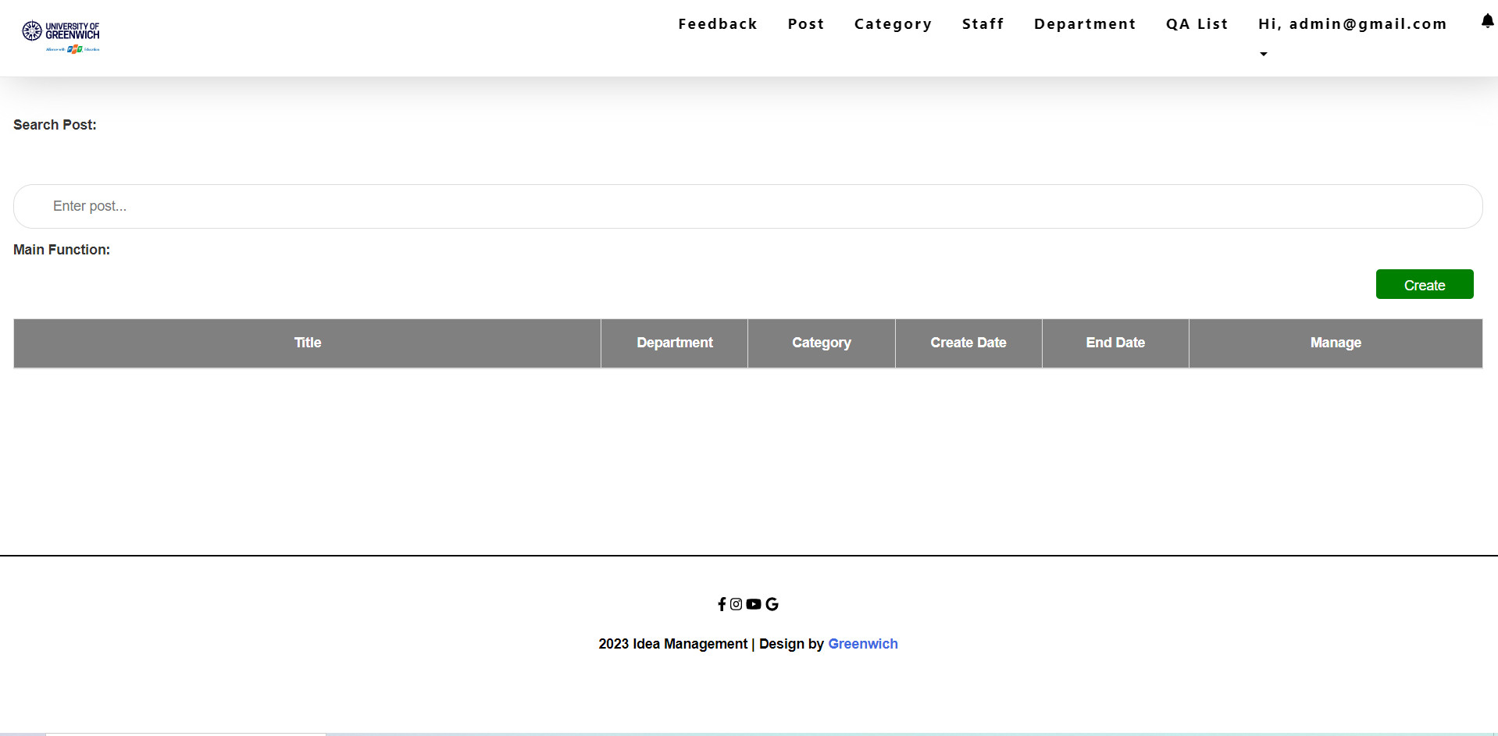

**Figure 92:** Post interface

**Explain:** This is the post interface, where admin can create posts and manage them like edit and delete

* **Create post**

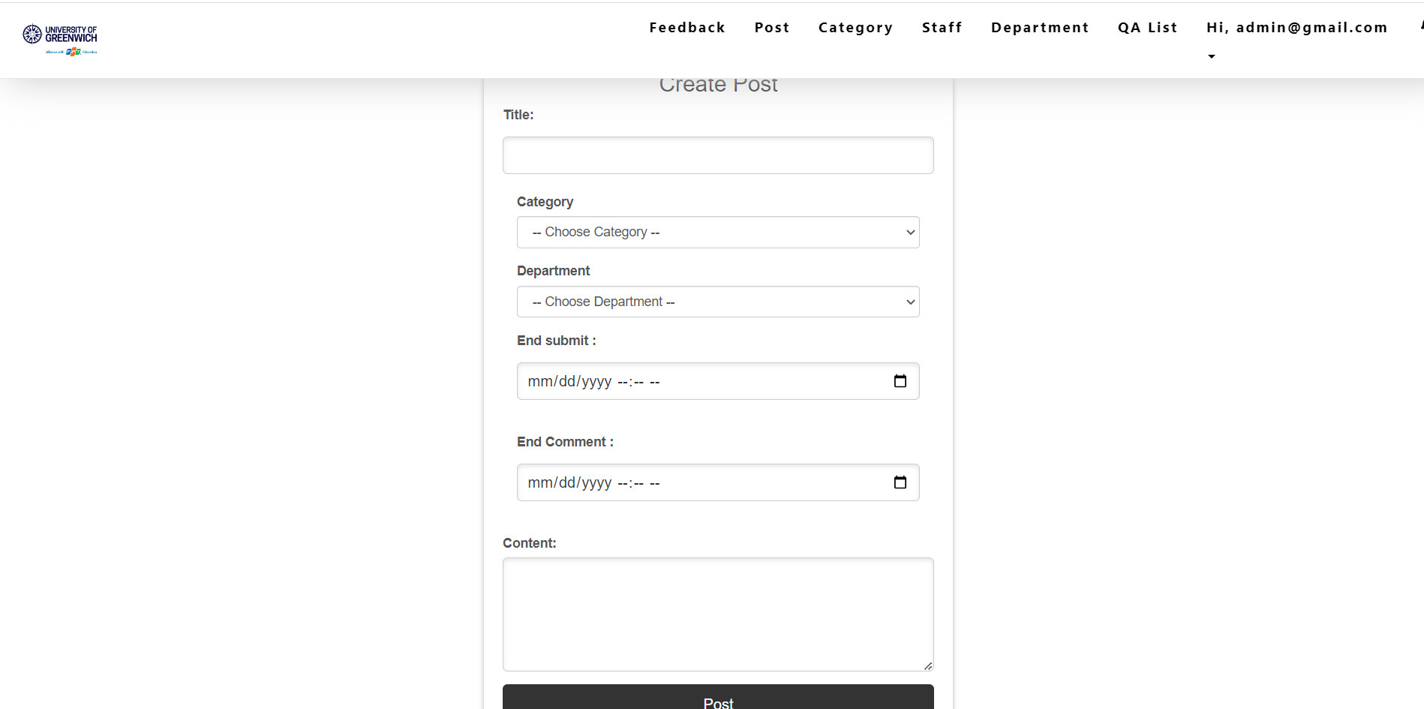

**Figure 93:** Create post

**Explain:** This is the "Create Post" interface after the admin presses the create button in the post interface. Here admin can fill in the post's information and press the "Post" button to create a new post.

* **Add post information**

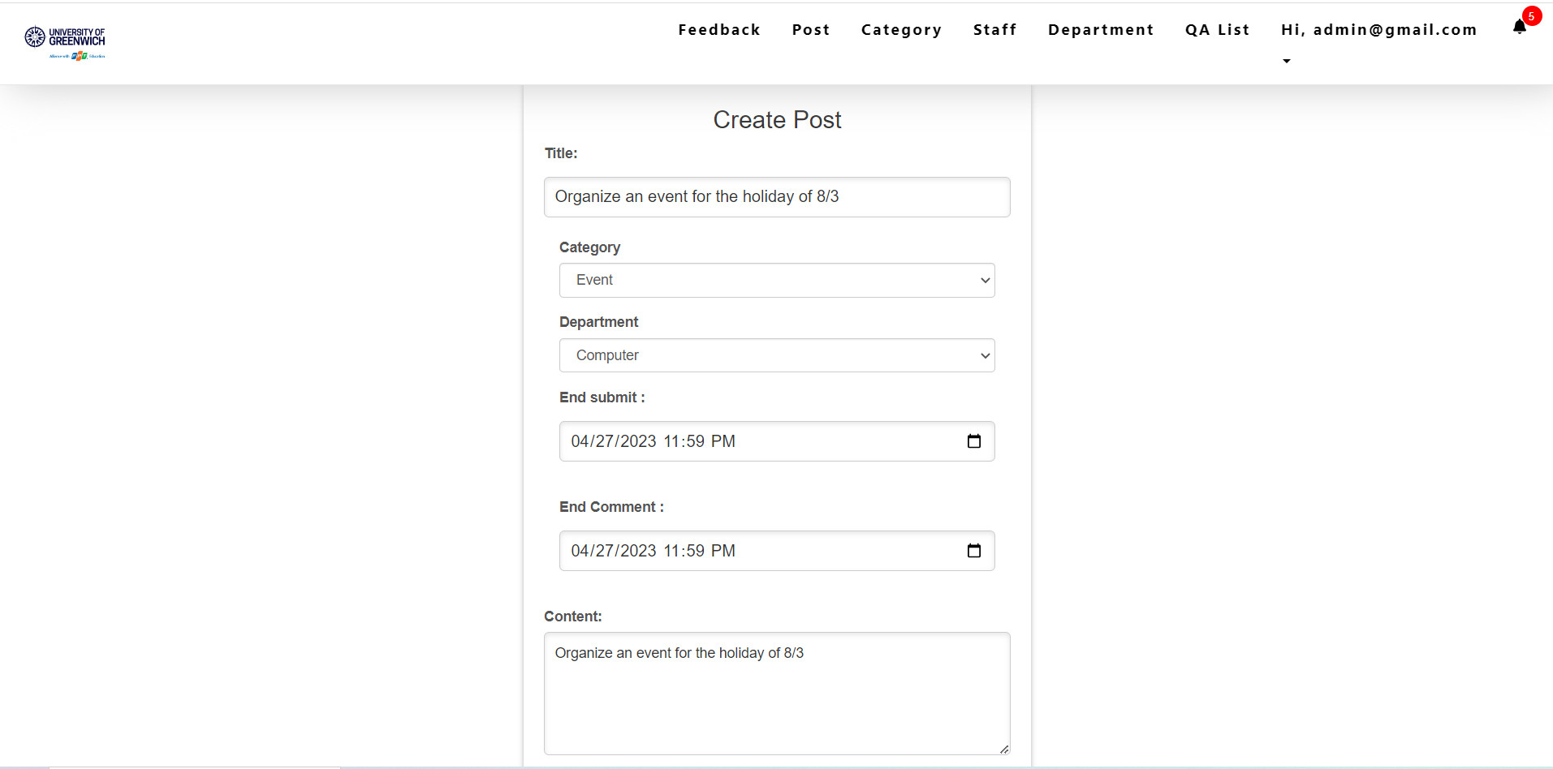

**Figure 94:** Add post information

**Explain:** This is what it looks like after I add information to the post.

* **Show post information**

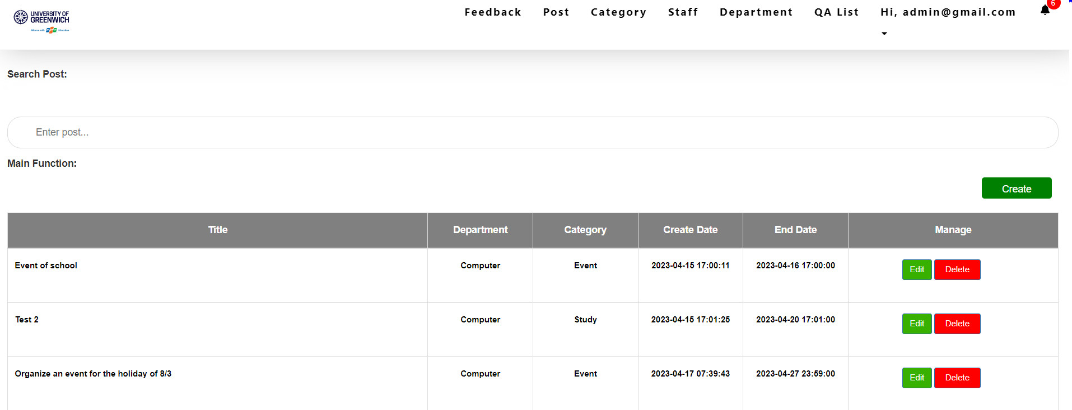

**Figure 95:** Show post information

**Explain:** After filling in the post information, press the "Post" button on the "Create Post" page. Post information will be displayed here.

* **Edit post**



**Figure 96:** Edit post interface

**Explain:** This is the post edit interface, in this interface admin can change the post's information.

* **After edit post**

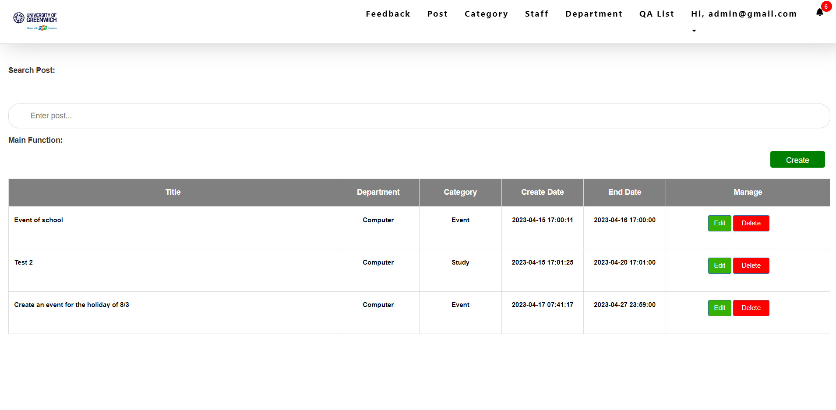

**Figure 97:** After edit post

**Explain:** This is the interface after changing the title information of the post.

* **Delete post**

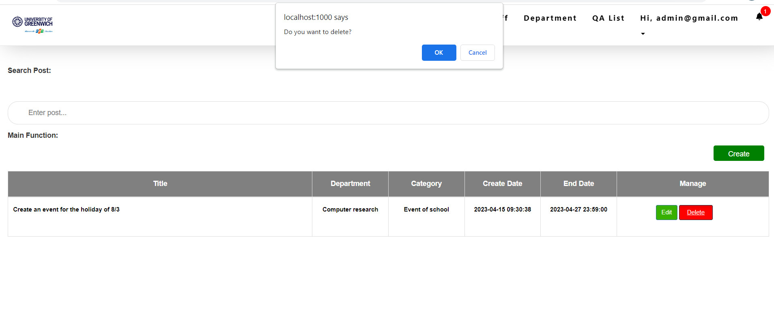

**Figure 98:** Delete post

**Explain:** After pressing the delete button in the interface, the message line "Do you want to delete?". Users can choose "yes" to delete the post or select "no" to cancel.

* **QA list interface**

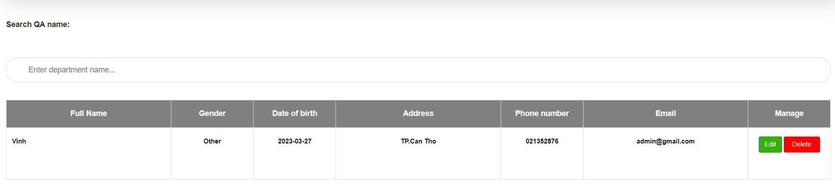

**Figure 99:** QA list interface

**Explain:** This is the QA list interface, where admin can manage them like edit and delete.

* **Staff interface**

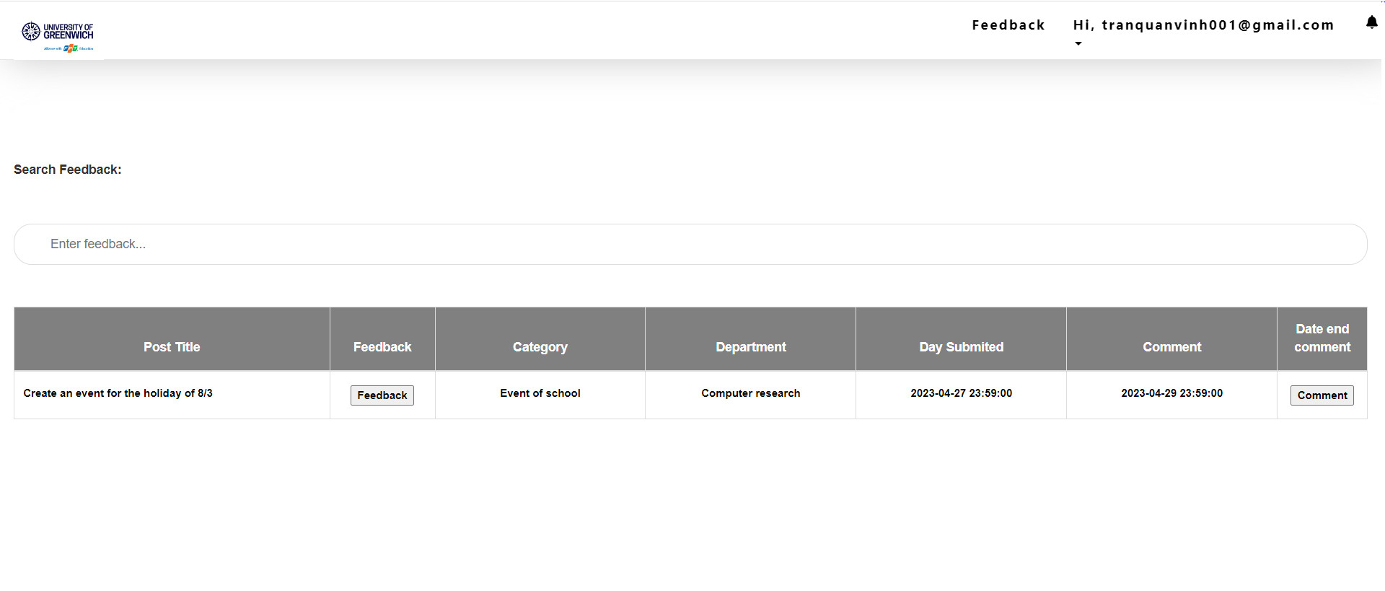

**Figure 100:** Staff interface

**Explain:** This is the feedback interface when the user login with staff account, in this interface staff can see post information and feedback about this post. In addition, staff can also view feedback and comment on existing feedback.

* **View post and feedback interface**

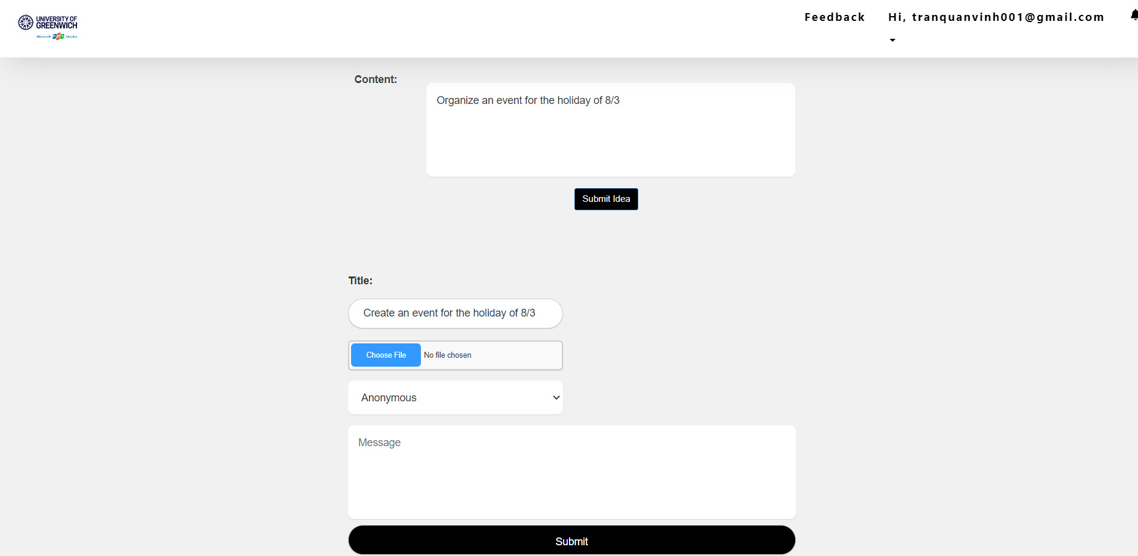

**Figure 101:** View post and feedback interface

**Explain:** This is the view post and feedback interface when the staff click the “feedback” button in feedback interface, in this interface staff can see post information and click “submit idea” to feedback about this post.

* **Submit idea information**

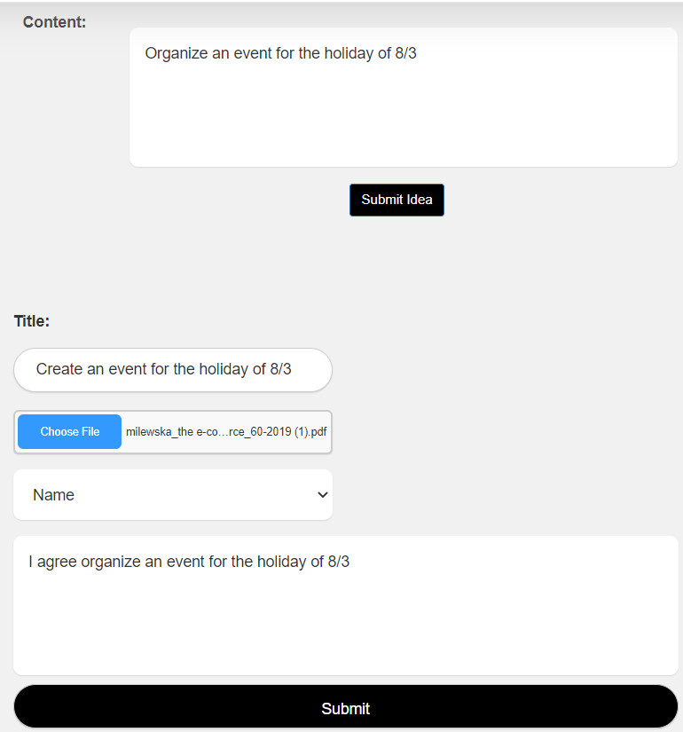

**Figure 102:** Submit idea information

**Explain:** This is what it looks like after I add information to the idea.

* **Idea information interface**

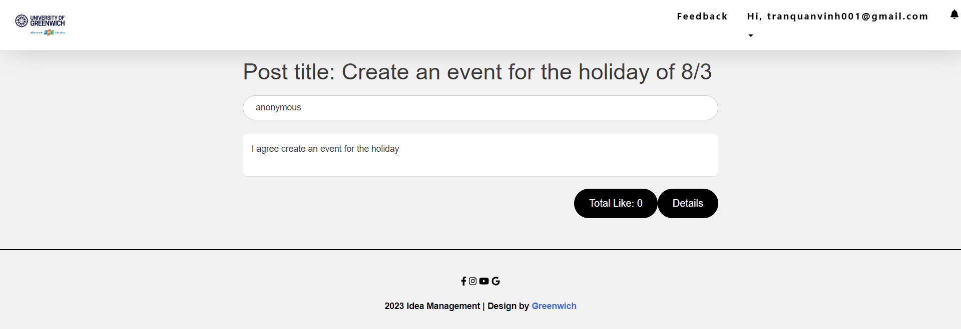

**Figure 103:** Idea information interface

**Explain:** Here is the idea information interface, here users can see full information of the idea such as total likes and content of the idea or click details to like and comment this idea.

* **Idea information interface with admin account**

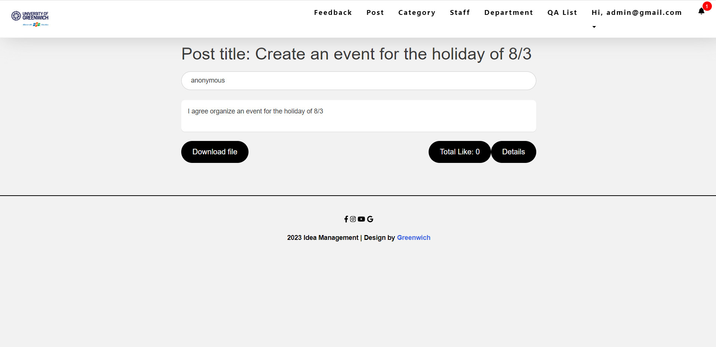

**Figure 104:** Idea information interface with admin account

**Explain:** Here is the idea information interface, here users can see full information of the idea such as total likes and content of the idea or click details to like and comment this idea and admin can click download file to see file of staff.

* **Comment idea interface**

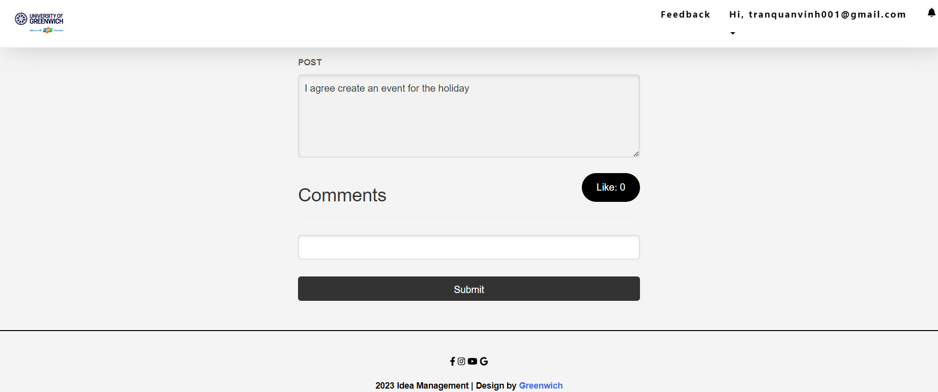

**Figure 105:** Comment idea interface

**Explain:** This is comment idea interface, in this interface user can comment and like idea

* **After comment and like idea**

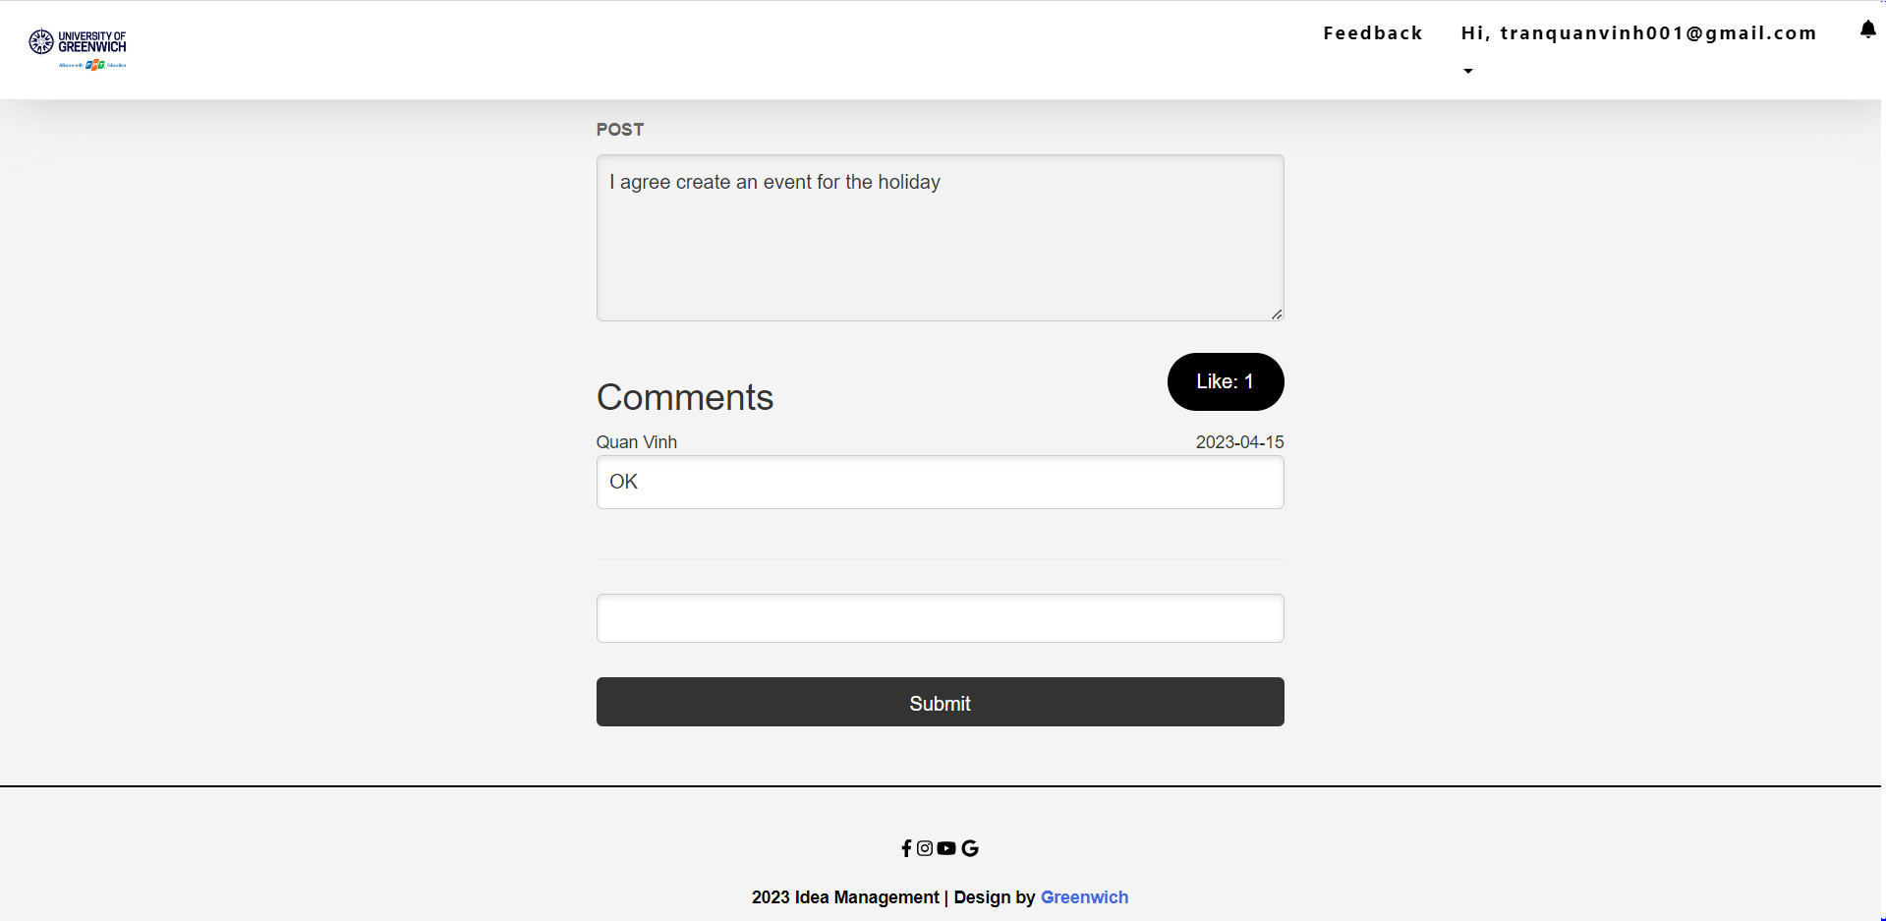

**Figure 106:** After comment and like idea

**Explain:** After commenting and liking the idea, the interface will display like this.

* **Update profile**

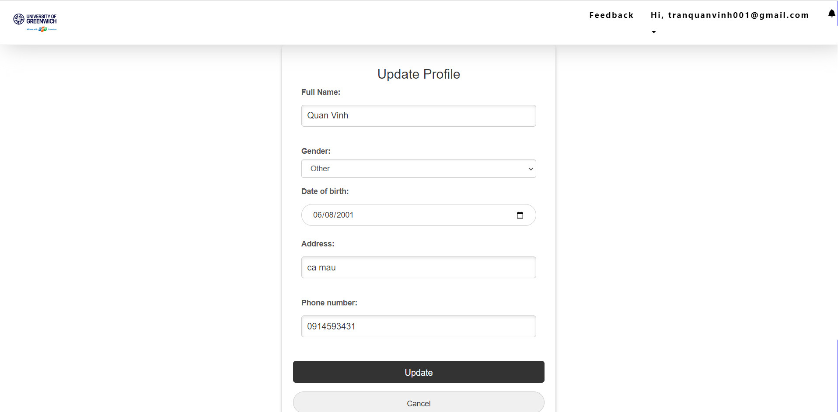

**Figure 107:** Update profile

**Explain:** This is the profile update interface, at this interface the user can change the information and press the "Update" button to change it.

* **Change password interface**

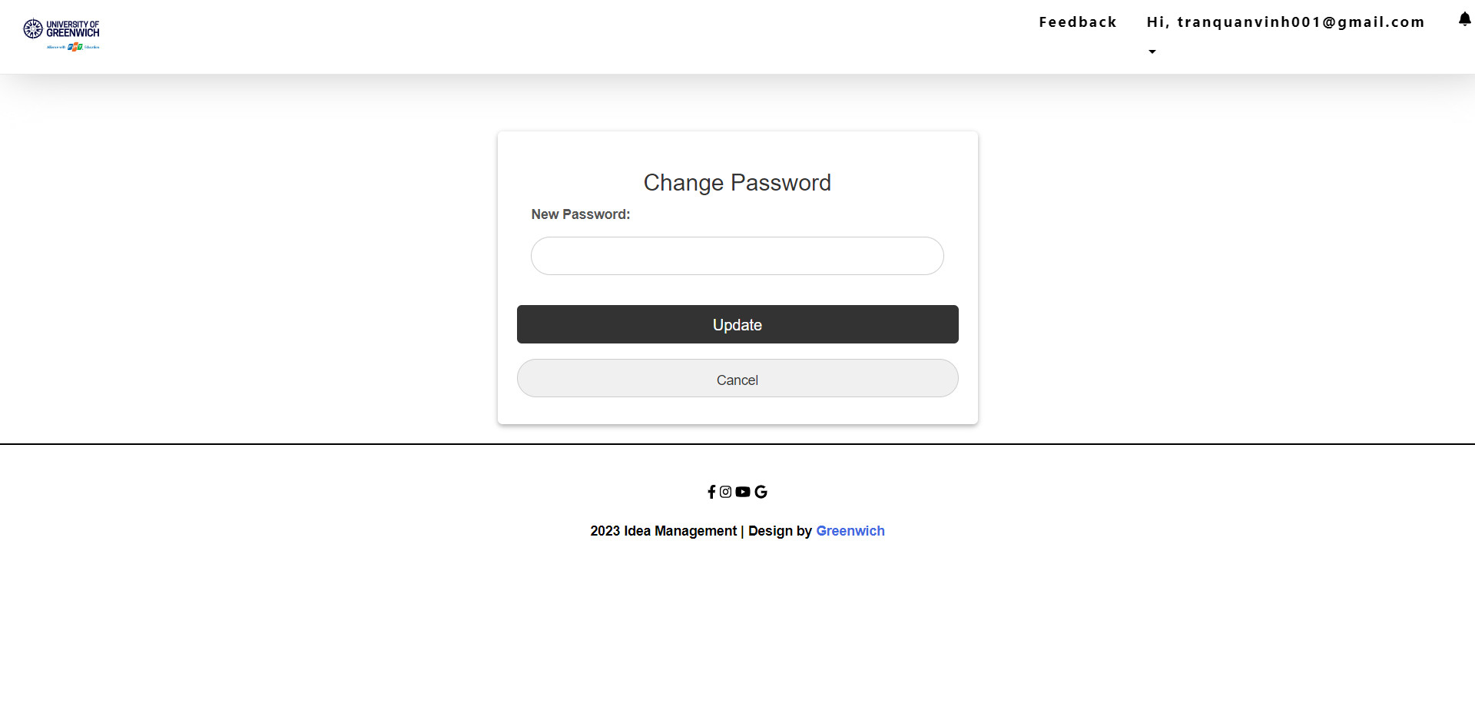

**Figure 108:** Change password interface

**Explain:** This is the password change interface, at this interface the user can change the account's password and press the "Update" button to change.

# **Testing**

## **Testing scope**

* Make sure the system functions are always working properly
* Assuring the effectiveness of the system.
* Testing time: 2/20/2023 – 4/17/2023.

## **Test details**

* The goal is to create appropriate test cases for every sprint and carry out testing.
* Requirement testing:
* Login/Logout
* Add, edit, delete department
* Add, edit, delete category
* Add, edit, delete post
* Deadline feedback
* Deadline comment
* Add, edit, delete staff
* Upload file
* Download file
* Update profile
* Change password
* Feedback
* Comment
* Like
* Notification
* Check button
* Test levels
* System Test
* Integration Test
* Acceptance Test

### **Sprint 1**

**Date:** 2/20/2023

**Table 4:** Test sprint 1

|  |  |  |  |  |  |  |
| --- | --- | --- | --- | --- | --- | --- |
| **User’s Story** | **Task** | **Test case description** | **Test input** | **Expected Output** | **Actual Output** | **Test Result** |
| Managers can add, edit, delete and review existing departments in the system. | Test CRUD department function | Create department | Enter department name: Computer | The added department information will be displayed on the department page as "Computer" | The added department information will be displayed on the department page as "Computer" | Pass |
| Edit department | Change department name information from "Computer" to "Business" | Department information that has been changed will be displayed from "Computer" to "Business" | Department information that has been changed will be displayed from "Computer" to "Business" | Pass |
| Delete department | Delete department name "Business" from department page | Department with name "Business" will disappear from department list | Department with name "Business" will disappear from department list | Pass |
| Check button | Delete department | Click delete button in department interface | The message "Do you want to delete" will be displayed | The message "Do you want to delete" will be displayed | Pass |
| Edit department | Click edit button in department interface | The edit department interface will be displayed | The edit department interface will be displayed | Pass |
| Create department | Click create button in department interface | The create department interface will be displayed | The create department interface will be displayed | Pass |

* **Achieving after sprint 1:**
* Create department
* Edit department
* Delete department
* Check create department button
* Check edit department button
* Check delete department button
* **Not achieving after sprint 1**: None

### **Sprint 2**

**Table 5:** Test sprint 2

|  |  |  |  |  |  |  |
| --- | --- | --- | --- | --- | --- | --- |
| **User’s Story** | **Task** | **Test case description** | **Test input** | **Expected Output** | **Actual Output** | **Test Result** |
| Managers can add, edit, delete and review existing category in the system. | Test CRUD category function | Create category | Enter category name: Event | The added category information will be displayed on the category page as " Event " | The added category information will be displayed on the category page as " Event " | Pass |
| Edit category | Change category name information from " Event " to "Study" | Category information that has been changed will be displayed from " Event " to "Study" | Category information that has been changed will be displayed from " Event " to "Study" | Pass |
| Delete category | Delete category name " Study " from category page | Category with name "Business" will disappear from category list | Category with name " Study " will disappear from category list | Pass |
| Check button | Delete category | Click delete button in category interface | The message "Do you want to delete" will be displayed | The message "Do you want to delete" will be displayed | Pass |
| Edit category | Click edit button in category interface | The edit category interface will be displayed | The edit category interface will be displayed | Pass |
| Create category | Click create button in category interface | The create category interface will be displayed | The create category interface will be displayed | Pass |

* **Achieving after sprint 2:**
* Create category
* Edit category
* Delete category
* Check create category button
* Check edit category button
* Check delete category button
* **Not achieving after sprint 2**: None

### **Sprint 3**

**Table 6:** Test sprint 3

|  |  |  |  |  |  |  |
| --- | --- | --- | --- | --- | --- | --- |
| **User’s Story** | **Task** | **Test case description** | **Test input** | **Expected Output** | **Actual Output** | **Test Result** |
| Managers can add, edit, delete and review existing post in the system. | Test CRUD post function | Create post | Enter post name: Organize an event for the holiday of 8/3  Category: Event  Department: Computer  End submit: 27/4/2023 11:59 PM  End comment: 27/4/2023 11:59 PM  Content: Organize an event for the holiday of 8/3 | The added post information will be displayed on the post page as:  Post name: Organize an event for the holiday of 8/3  Category: Event  Department: Computer  End submit: 27/4/2023 11:59 PM  End comment: 27/4/2023 11:59 PM  Content: Organize an event for the holiday of 8/3 | The added post information will be displayed on the post page as:  Post name: Organize an event for the holiday of 8/3  Category: Event  Department: Computer  End submit: 27/4/2023 11:59 PM  End comment: 27/4/2023 11:59 PM  Content: Organize an event for the holiday of 8/3 | Pass |
| Edit post | Change post name from: Organize an event for the holiday of 8/3 to “Create Organize an event holiday of 8/3”  Category: Event  Department: Computer  End submit: 27/4/2023 11:59 PM  End comment: 27/4/2023 11:59 PM  Content: Organize an event for the holiday of 8/3 | Post information that has been changed will be displayed from Organize an event for the holiday of 8/3 to “Create Organize an event holiday of 8/3”  Category: Event  Department: Computer  End submit: 27/4/2023 11:59 PM  End comment: 27/4/2023 11:59 PM  Content: Organize an event for the holiday of 8/3 | Post information that has been changed will be displayed from Organize an event for the holiday of 8/3 to “Create Organize an event holiday of 8/3”  Category: Event  Department: Computer  End submit: 27/4/2023 11:59 PM  End comment: 27/4/2023 11:59 PM  Content: Organize an event for the holiday of 8/3 | Pass |
| Delete post | Delete post name " Create Organize an event holiday of 8/3” | Post with name " Create Organize an event holiday of 8/3" will disappear from post list | Post with name " Create Organize an event holiday of 8/3" will disappear from post list | Pass |
| Check button | Delete post | Click delete button in post interface | The message "Do you want to delete" will be displayed | The message "Do you want to delete" will be displayed | Pass |
| Edit post | Click edit button in post interface | The edit post interface will be displayed | The edit post interface will be displayed | Pass |
| Create post | Click create button in post interface | The create post interface will be displayed | The create post interface will be displayed | Pass |

* **Achieving after sprint 3:**
* Create post
* Edit post
* Delete post
* Check create post button
* Check edit post button
* Check delete post button
* **Not achieving after sprint 3**: None

### **Sprint 4**

**Table 7:** Test sprint

|  |  |  |  |  |  |  |
| --- | --- | --- | --- | --- | --- | --- |
| **User’s Story** | **Task** | **Test case description** | **Test input** | **Expected Output** | **Actual Output** | **Test Result** |
| Managers can add, edit, delete and review existing staff (staff account) in the system. | Test CRUD staff function | Create staff | Enter staff fullname:  Tran Quan Vinh  Gender: Male  Role: Staff  Department: Computer  Date of birth: 06/06/2001  Address: Ca Mau  Phone number: 0123456789  Email: vinh@gmail.com | The added staff information will be displayed on the staff page as:  Fullname: Tran Quan Vinh  Gender: Male  Role: Staff  Department: Computer  Date of birth: 06/06/2001  Address: Ca Mau  Phone number: 0123456789  Email: vinh@gmail.com | The added staff information will be displayed on the staff page as:  Fullname: Tran Quan Vinh  Gender: Male  Role: Staff  Department: Computer  Date of birth: 06/06/2001  Address: Ca Mau  Phone number: 0123456789  Email: vinh@gmail.com | Pass |
| Edit staff | Change staff fullname from: “Tran Quan Vinh” to “Quan Vinh”  Gender: Male  Role: Staff  Department: Computer  Date of birth: 06/06/2001  Address: Ca Mau  Phone number: 0123456789  Email: [vinh@gmail.com](mailto:vinh@gmail.com) | Staff information that has been changed will be displayed from “Tran Quan Vinh” to “Quan Vinh”  Role: Staff  Department: Computer  Date of birth: 06/06/2001  Address: Ca Mau  Phone number: 0123456789  Email: [vinh@gmail.com](mailto:vinh@gmail.com) | Staff information that has been changed will be displayed from “Tran Quan Vinh” to “Quan Vinh”  Role: Staff  Department: Computer  Date of birth: 06/06/2001  Address: Ca Mau  Phone number: 0123456789  Email: [vinh@gmail.com](mailto:vinh@gmail.com) | Pass |
| Delete staff | Delete staff fullname "Quan Vinh” | Staff with fullname "Quan Vinh" will disappear from post list | Staff with fullname "Quan Vinh" will disappear from post list | Pass |
| Check button | Delete staff | Click delete button in staff interface | The message "Do you want to delete" will be displayed | The message "Do you want to delete" will be displayed | Pass |
| Edit staff | Click edit button in staff interface | The edit staff interface will be displayed | The edit staff interface will be displayed | Pass |
| Create staff | Click create button in staff interface | The create staff interface will be displayed | The create staff interface will be displayed | Pass |

* **Achieving after sprint 4:**
* Create staff
* Edit staff
* Delete staff
* Check create staff button
* Check edit staff button
* Check delete staff button
* **Not achieving after sprint 4**: None

### **Sprint 5**

**Table 8:** Test sprint 5

|  |  |  |  |  |  |  |
| --- | --- | --- | --- | --- | --- | --- |
| **User’s Story** | **Task** | **Test case description** | **Test input** | **Expected Output** | **Actual Output** | **Test Result** |
| All users will receive a notification when someone comments on their feedback  or when QA create post for them | Test notifications for user | Check the notification function when someone comments on an staff feedback | Use another account to comment on staff feedback | The notification bell will display the number 1, and when pressed, it will display the message of the commenter. | The notification bell will display the number 1, and when pressed, it will display the message of the commenter. | Pass |
| Check the notification function when admin create post for them | Use QA account and create post | The notification bell will display the number 1, and when pressed, it will display the message of the new post. | The notification bell will display the number 1, and when pressed, it will display the message of the new post. | Pass |
| The number displayed in the bell will disappear when the user clicks to view the message | Click the number displayed on the bell to see new notifications | The number displayed in the bell will disappear | The number displayed in the bell will disappear | Pass |
| Click the bell to see old notifications | Click the notification bell | Old notifications will be displayed again | Nothing happens when the bell is pressed | Fail |

* **Achieving after sprint 5:**
* Check the notification function when someone comments on an staff feedback
* Check the notification function when admin create post for them
* The number displayed in the bell will disappear when the user clicks to view the message
* Click the bell to see old notifications
* **Not achieving after sprint 5**: 1 (Click the bell to see old notifications)

### **Sprint 6**

**Table 9:** Test print 6

|  |  |  |  |  |  |  |
| --- | --- | --- | --- | --- | --- | --- |
| **User’s Story** | **Task** | **Test case description** | **Test input** | **Expected Output** | **Actual Output** | **Test Result** |
| Staff can post feedback on post they can see | Verify upload feedback function | Upload feedback | Title: Suggestion on IT  Content: Should add more Java courses  Choose anonymous or your name  File upload: 1 PDF may or may not be available  Enter feedback about: IT | All information about feedback will be displayed in the comments page and every can see and comment like as:  Title: feedback on IT  Content: “Should add more Java courses”  Select topic: IT  File upload: 1 PDF yes or no  Enter feedback about: IT | All information about feedback will be displayed in the comments page and every can see and comment like as:  Title: feedback on IT  Content: “Should add more Java courses”  Select topic: IT  File upload: 1 PDF yes or no  Enter feedback about: IT | Pass |
| Upload file in PDF | Click the button “Choose file” and select file PDF and fill the information after that click submit button | The file will be added and QA can download it in the comment page. | The file will be added and QA can download it in the comment page. | Pass |
| Staff can comment and like on feedback they can see | Verify “Comment and like feedback” function | User can comment feedback | Username: Quan Vinh  Enter text: “I agree”  At: 4-17-2023 10:20:31 AM  And click submit button | Comments show with the following data  Commenter’s name: “Quan Vinh”  Comment date: “4-17-2023”  Comment text: “I agree” | Comments show with the following data  Commenter’s name: “Quan Vinh”  Comment date: “4-17-2023”  Comment text: “I agree” | Pass |
| User can like feedback | Click the like button in the comment pages | Depending on the number of likes, the like button will display from 0 to 1 or 1 to 2. Each individual may only press it once, and doing so a second time will cancel that turn. | Depending on the number of likes, the like button will display from 0 to 1 or 1 to 2. Each individual may only press it once, and doing so a second time will cancel that turn. | Pass |

* **Achieving after sprint 6:**
* Upload feedback
* Upload file in PDF
* User can comment feedback
* User can like feedback
* **Not achieving after sprint 6**: None

# **Agile Scrum implementation**

Scrum is a framework that provides users with a range of techniques and processes for effective application management and product development through continuous iteration. Our team adopted the Scrum methodology to manage and develop the application in this project, and we have been able to witness the effectiveness of this approach firsthand (Peek, 2023).

## **6.1 Product backlog**

A list of system requirements considered necessary is maintained in the form of a Product Backlog, which serves as the central repository for tracking any changes to the product. The Product Owner has the responsibility of managing the availability, contents and priority of the requirements enlisted in the Product Backlog (Raeburn, 2022).

**Table 10:** Product backlog

|  |  |  |  |  |  |  |  |
| --- | --- | --- | --- | --- | --- | --- | --- |
| PRODUCT BACKLOG | | | | | | | |
| ID | Categories | Role | Action | Explanation | Priority | Status | Note |
| 1 | CRUD | QA Manager | CRUD Department | Administrators can create a new department or update, view and delete existing departments | Must have | Done |  |
| 2 | CRUD | QA Manager | CRUD Category | Admin can create new categories or update, view and delete existing categories | Must have | Done |  |
| 3 | CRUD | QA Manager | CRUD Topic | Admin can create new topic or update, view and delete existing topics | Must have | Done |  |
| 4 | CRUD | QA Manager | CRUD Staff account | Admin can create new staff account or update, view and delete existing staff account | Must have | Done |  |
| 5 | Viewing | QA Manager | Viewing topic | They can view previously created topics and feedback. | Must have | Done |  |
| 6 | Comment | QA Manager | Comment feedback | Managers can comment on feedback already posted by others | Must have | Done |  |
| 7 | Notification | Staff | Notification for user | When someone comments on the feedback, a notification will be sent to the person who posted that feedback. | Must have | Done |  |
| 8 | Viewing | Staff | View topic, feedback | Users can view topics belonging to their department and see feedback on those topics | Must have | Done |  |
| 9 | Posting | Staff | Post feedback | When they see a topic in their department, they can post feedback on that topic. | Must have | Done |  |
| 10 | Comment | Staff | Comment feedback | They can comment on feedback on topics in their department | Must have | Done |  |
| 11 | Updating | Staff | Update account | Staff can update basic information in their account | Must have | Done |  |

The Product Backlog of the website, defined by the given specifications, is seamlessly presented in the figure. Each item in the backlog has four crucial components, namely role, action, explanation, and priority. Our application has effectively met all user requirements outlined in the Product Backlog.

During the development process, we gave the utmost priority to the 'Must have' requirements to ensure system reliability, given their criticality.

## **6.2 Sprint backlogs**

The Sprint Backlog is a crucial management tool that assists the development team in executing work during a Sprint effectively. Each Sprint Backlog comprises Product Backlog Items that the development team has selected for the current Sprint, along with a comprehensive work plan to achieve the Sprint Goal.

Primarily, the Sprint Backlog is represented in the form of a task table that breaks down user stories and tasks that need completion. The development team has the authority to update the Sprint Backlog throughout the Sprint, by adding new tasks or removing unnecessary ones.

In the Sprint Backlog, tasks or jobs can be assigned a status, such as 'To Do', 'In Progress', and 'Done'. Moreover, when a task is marked as "Done", the estimated value of that task is instantly updated.

(Asana, 2022)

### **6.2.1 Sprint 1**

**Table 11:** Sprint 1

|  |  |  |  |  |  |  |  |  |  |  |  |  |
| --- | --- | --- | --- | --- | --- | --- | --- | --- | --- | --- | --- | --- |
| SPRINT 1 | | | | | | | | | | | | |
| ID | User’s story | Task | Owner | Estimated hours | Day 1  (20/2) | Day  (21/2) | Day  (22/2) | Day  (23/2) | Day  (24/2) | Day  (25/2) | Day  (26/2) | Status |
| 1 | Managers can add, edit, delete and review existing departments in the system. | Code department interface | Vinh | 14 | 2 | 3 | 2 | 2 | 3 | 2 | 0 | Completed |
| Database design + connect | Duy | 10 | 3 | 0 | 0 | 3 | 2 | 0 | 2 | Completed |
| Code create department | Quan | 10 | 3 | 3 | 0 | 0 | 2 | 2 | 0 | Completed |
| Code update department | Duy | 8 | 0 | 3 | 3 | 0 | 0 | 2 | 0 | Completed |
| Code delete department | Phat | 10 | 2 | 2 | 0 | 0 | 3 | 3 | 0 | Completed |
| Testing | Phat + Quan | 10 | 0 | 0 | 4 | 3 | 0 | 0 | 3 | Completed |

In Sprint 1, we started with coding necessary Department functions. Department is used to divide the staff in the company, they will be allocated in the department they work, then they will be able to see the categories of that department created by the QA Manager. QA Mangers can create new parts or distribute existing ones to their staff.

We will first implement the interface code of the system as well as the interface of the department management page (front-end), then will design the database based on the previous designs to store the necessary data, next will be the functions in CRUD and finally will be the test to catch and fix the error.

All the goals we set in the Sprint were completed well, most of the early days we achieved many of the goals we set, but in the later times we started to slow down and balance with the goal. original pepper

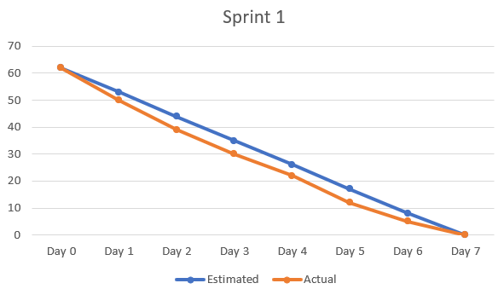

|  |  |  |  |  |  |  |  |  |
| --- | --- | --- | --- | --- | --- | --- | --- | --- |
| Estimated | 62 | 53 | 44 | 35 | 26 | 17 | 8 | 0 |
| Actual | 60 | 50 | 39 | 30 | 22 | 12 | 5 | 0 |

**Figure 109:** Burndown chart of sprint 1

### **6.2.1 Sprint 2**

**Table 12:** Sprint 2

|  |  |  |  |  |  |  |  |  |  |  |  |  |
| --- | --- | --- | --- | --- | --- | --- | --- | --- | --- | --- | --- | --- |
| SPRINT 2 | | | | | | | | | | | | |
| ID | User’s story | Task | Owner | Estimated hours | Day  (27/2) | Day  (28/2) | Day  (1/3) | Day  (2/3) | Day  (3/3) | Day  (4/3) | Day  (5/3) | Status |
| 2 | Managers can add, edit, delete and review existing category in the system. | Code category interface | Vinh | 12 | 3 | 0 | 3 | 2 | 2 | 2 | 0 | Completed |
| Database design + connect | Duy | 9 | 3 | 0 | 2 | 2 | 2 | 0 | 0 | Completed |
| Code create category | Quan | 10 | 0 | 3 | 0 | 4 | 3 | 0 | 0 | Completed |
| Code update category | Duy | 8 | 0 | 3 | 0 | 0 | 0 | 3 | 2 | Completed |
| Code delete category | Phat | 7 | 0 | 3 | 0 | 2 | 2 | 0 | 0 | Completed |
| Testing | Phat + Quan | 10 | 3 | 0 | 2 | 0 | 0 | 2 | 3 | Completed |

Category is the category of the topic, a category can contain many topics, when creating a topic, you must choose a category for that topic, each topic can only choose one category.

We will first implement the interface code of the system as well as the interface of the category management page (front-end), then will design the database based on the previous designs to store the necessary data, next will be the functions in CRUD and finally will be the test to catch and fix the error.

All the goals that we had set for the Sprint have been successfully accomplished. We managed to achieve a significant portion of the goals set early on in the Sprint; however, towards the end, there was a slight slowdown where we had to make a conscious effort to balance and align ourselves with the original Sprint goal.

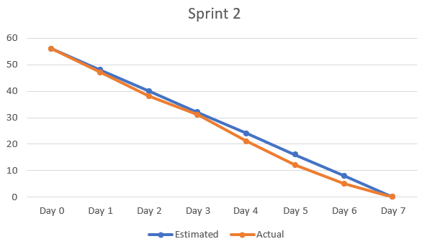

|  |  |  |  |  |  |  |  |  |
| --- | --- | --- | --- | --- | --- | --- | --- | --- |
| Estimated | 56 | 48 | 40 | 32 | 24 | 16 | 8 | 0 |
| Actual | 56 | 47 | 38 | 31 | 21 | 12 | 5 | 0 |

**Figure 110:** Burndown chart of sprint 2

### **6.2.3 Sprint 3**

**Table 13:** Sprint 3

|  |  |  |  |  |  |  |  |  |  |  |  |  |
| --- | --- | --- | --- | --- | --- | --- | --- | --- | --- | --- | --- | --- |
| SPRINT 3 | | | | | | | | | | | | |
| ID | User’s story | Task | Owner | Estimated hours | Day  (6/3) | Day  (7/3) | Day  (8/3) | Day  (9/3) | Day  (10/3) | Day  (11/3) | Day  (12/3) | Status |
| 3 | Managers can add, edit, delete and review existing post in the system. | Code post interface | Vinh | 11 | 3 | 3 | 0 | 0 | 2 | 0 | 3 | Completed |
| Database design + connect | Duy | 9 | 3 | 0 | 2 | 2 | 0 | 0 | 2 | Completed |
| Code create post | Quan | 8 | 3 | 3 | 0 | 2 | 0 | 0 | 0 | Completed |
| Code update post | Quan | 7 | 0 | 0 | 2 | 0 | 3 | 2 | 0 | Completed |
| Code delete post | Phat | 7 | 3 | 0 | 2 | 2 | 0 | 0 | 0 | Completed |
| Testing | Duy + Phat | 10 | 0 | 2 | 0 | 0 | 2 | 3 | 3 | Completed |

Post are topics created by the QA Manager for a certain department and for a certain category, staff can comment on post belonging to their department.

We will first implement the interface code of the system (front-end), then will design the database based on the previous designs to store the necessary data, next will be the functions in CRUD and finally will be the test to catch and fix the error.

All the objectives of the Sprint were effectively met as intended. At the beginning of the Sprint, we were able to achieve a substantial part of the initial objectives swiftly. Nevertheless, towards the end, we experienced a slight deceleration, which required us to make a conscious effort to regain balance and align ourselves with the original Sprint goal.

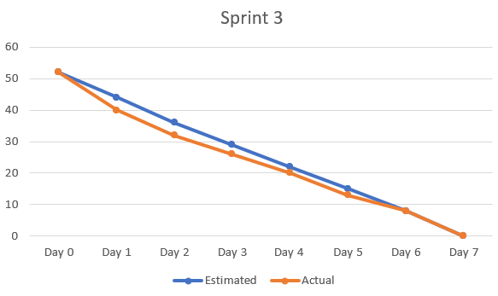

|  |  |  |  |  |  |  |  |  |
| --- | --- | --- | --- | --- | --- | --- | --- | --- |
| Estimated | 52 | 44 | 36 | 29 | 22 | 15 | 8 | 0 |
| Actual | 52 | 40 | 32 | 26 | 20 | 13 | 8 | 0 |

**Figure 111:** Burndown chart of sprint 3

### **6.2.4 Sprint 4**

**Table 14:** Sprint 4

|  |  |  |  |  |  |  |  |  |  |  |  |  |
| --- | --- | --- | --- | --- | --- | --- | --- | --- | --- | --- | --- | --- |
| SPRINT 4 | | | | | | | | | | | | |
| ID | User’s story | Task | Owner | Estimated hours | Day  (13/3) | Day  (14/3) | Day  (15/3) | Day  (16/3) | Day  (17/3) | Day  (18/3) | Day  (19/3) | Status |
| 4 | Managers can add, edit, delete and review existing staff (staff account) in the system. | Code staff interface | Vinh | 10 | 3 | 0 | 2 | 3 | 3 | 0 | 0 | Completed |
| Database design + connect | Duy | 8 | 2 | 0 | 2 | 2 | 0 | 0 | 2 | Completed |
| Code create staff | Quan | 7 | 3 | 0 | 2 | 0 | 0 | 2 | 0 | Completed |
| Code update staff | Quan | 6 | 0 | 2 | 0 | 2 | 2 | 0 | 0 | Completed |
| Code delete staff | Phat | 7 | 3 | 0 | 2 | 2 | 0 | 0 | 0 | Completed |
| Testing | Duy + Phat | 10 | 0 | 3 | 0 | 0 | 0 | 3 | 4 | Completed |

Staff is the manager staff in the company, the employee account will be created by the QA manager and given to the employee, they cannot create any for themselves. When creating an account, the QA Manager will select the department belonging to that employee.

We will first implement the interface code of the system (front-end), then will design the database based on the previous designs to store the necessary data, next will be the functions in CRUD and finally will be the test to catch and fix the error.

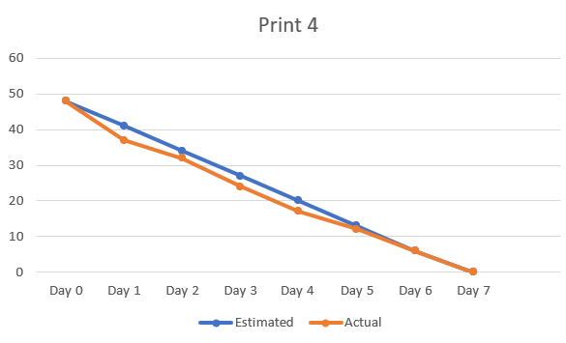

|  |  |  |  |  |  |  |  |  |
| --- | --- | --- | --- | --- | --- | --- | --- | --- |
| Estimated | 48 | 41 | 34 | 27 | 20 | 13 | 6 | 0 |
| Actual | 48 | 37 | 32 | 24 | 17 | 12 | 6 | 0 |

**Figure 112:** Burndown chart of sprint 4

### **6.2.5 Sprint 5**

**Table 15:** Sprint 5

|  |  |  |  |  |  |  |  |  |  |  |  |  |
| --- | --- | --- | --- | --- | --- | --- | --- | --- | --- | --- | --- | --- |
| SPRINT 5 | | | | | | | | | | | | |
| ID | User’s story | Task | Owner | Estimated hours | Day  (20-21/3) | Day  (22-23/3) | Day  (24-25/3) | Day  (26-27/3) | Day  (28-29/3) | Day  (30-31/3) | Day  (1-2/4) | Status |
| 5 | Manager can see all post added by them or another administrator | Code view post with admin account | Phat | 15 | 3 | 4 | 0 | 4 | 4 | 0 | 0 | Completed |
| Testing | Quan | 12 | 3 | 3 | 0 | 4 | 2 | 0 | 0 | Completed |
| 6 | Manager can see all comments of all feedback | Code comment feedback with admin account | Duy | 18 | 2 | 3 | 4 | 3 | 3 | 3 | 0 | Completed |
| Database design + connect | Duy | 8 | 3 | 2 | 2 | 0 | 0 | 0 | 0 | Completed |
| Testing | Quan | 12 | 0 | 0 | 3 | 0 | 2 | 3 | 4 | Completed |
| 7 | All users will receive a notification when someone comments on their feedback | Coded notification for user | Vinh | 24 | 4 | 4 | 4 | 3 | 2 | 3 | 4 | Completed |
| Testing | Phat | 8 | 0 | 0 | 2 | 0 | 0 | 3 | 3 | Completed |

In Sprint 5, the time is 2 weeks for a Sprint, unlike the first 4 prints because its work is more complicated. In Print 5, we proceed to perform the necessary functions. In Sprint 5 and 6, the time is 2 weeks for a Sprint, unlike the first 4 prints because the work is more complicated. In Print 5, we proceed to perform the necessary functions. Almost in week 5 will be functions for QA Manager.

Viewing post will be 2 different modes, for QA manager, they can see all topics, followed by the comment section with each topic, almost everything is the same for staff. The next function we do in this sprint is the notification function, which is probably the most difficult function in this system.

For these functions, there is no need to create a new database because it will mostly be based on the databases created from that, first the code view post for the QA Manager account and its interface, then perform the testing step. , next will be the comment feedback code and create a database to store comments and likes of that comment, next will be testing. Next will be the functional code that notifies all users and performs testing.

The Sprint's objectives were successfully accomplished according to plan. We rapidly achieved a considerable portion of the initial objectives during the Sprint's onset. However, towards the end, we experienced a minor deceleration, which called for a deliberate attempt to restore equilibrium while staying true to the original Sprint goal.

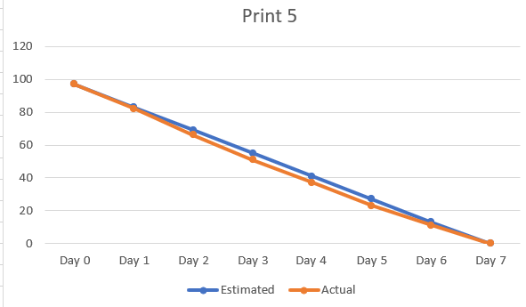

|  |  |  |  |  |  |  |  |  |
| --- | --- | --- | --- | --- | --- | --- | --- | --- |
| Estimated | 97 | 83 | 69 | 55 | 41 | 27 | 13 | 0 |
| Actual | 97 | 82 | 66 | 51 | 37 | 23 | 11 | 0 |

**Figure 113:** Burndown chart of sprint 5

### **6.2.6 Sprint 6**

**Table 16:** Sprint 6

|  |  |  |  |  |  |  |  |  |  |  |  |  |
| --- | --- | --- | --- | --- | --- | --- | --- | --- | --- | --- | --- | --- |
| SPRINT 6 | | | | | | | | | | | | |
| ID | User’s story | Task | Owner | Estimated hours | Day  (3-4/4) | Day  (5-6/4) | Day  (7-8/4) | Day  (9-10/4) | Day  (11-12/4) | Day  (13-14/4) | Day  (15-16/4) | Status |
| 8 | Staff can view post and feedback based on their department | Code view post with staff account | Phat | 14 | 4 | 5 | 4 | 0 | 1 | 0 | 0 | Completed |
| Code view feedback | Phat | 10 | 2 | 0 | 3 | 0 | 5 | 0 | 0 | Completed |
| Testing | Quan + Duy | 14 | 5 | 0 | 0 | 0 | 5 | 0 | 4 | Completed |
| 9 | Staff can post feedback on post they can see | Code post feedback | Vinh | 15 | 3 | 3 | 0 | 3 | 2 | 0 | 4 | Completed |
| Testing | Quan | 10 | 4 | 4 | 2 | 0 | 0 | 0 | 0 | Completed |
| 10 | Staff can comment and like on feedback they can see | Code comment feedback with staff account | Vinh | 12 | 0 | 0 | 4 | 3 | 2 | 3 | 0 | Completed |
| Testing | Phat + Duy | 15 | 0 | 0 | 3 | 3 | 0 | 4 | 5 | Completed |
| 11 | They can update some basic information about themselves | Code update staff account | Quan | 12 | 0 | 3 | 4 | 2 | 0 | 3 | 0 | Completed |
| Testing | Duy | 10 | 0 | 5 | 0 | 2 | 3 | 0 | 0 | Completed |

For Staff, they only see topics in their department and post feedback related to that post, they can comment on those feedbacks and drop the "Like" expression on the comments, Staff can Update some basic information based on the account created previously by QA Manager.

For the staff topic view function, they need the developer to divide the department, we will not conduct testing at this time but will continue to code the feedback view and then do the testing. Next will be the post feedback code, this is the most important part of the system. The last 2 functions are the function of commenting feedback and updating the staff's account.

The goals of the Sprint were successfully completed as expected. We quickly met a sizable chunk of the basic goals when the Sprint first started. We did, however, encounter a slight slowing at the conclusion, which required a concerted effort to restore equilibrium while adhering to the original Sprint objective.

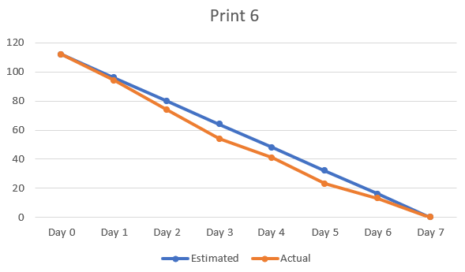

|  |  |  |  |  |  |  |  |  |
| --- | --- | --- | --- | --- | --- | --- | --- | --- |
| Estimated | 112 | 96 | 80 | 64 | 48 | 32 | 16 | 0 |
| Actual | 112 | 94 | 74 | 54 | 41 | 23 | 13 | 0 |

**Figure 114:** Burndown chart of sprint 6

## **6.3 Minute of daily meeting**

The Daily Scrum is a short 15-minute meeting where the development team comes together to review their progress towards achieving the Sprint goal and assess their performance in accomplishing tasks listed in the Sprint backlog.

### **6.3.1 Sprint 1**

**Table 17:** Daily meeting sprint 1

|  |  |  |
| --- | --- | --- |
| Date | Hours | Attendance |
| 20-2-2023 | 14:00 – 15:00 | 4/4 |
|  | | |
| Meeting face to face | | |
|  | | |
| Topics | | |
| Discuss the tasks to be done and divide the work | | |
| Bringing out the best technology for each person's work | | |
| Tasks | | |
| Where will the team leader divide the work for 2 weeks | | |
| Members have to give their own opinions | | |

In the first group meeting is the first day of work. We need to put the work that needs to be done on this project, and come up with the latest and most appropriate tools and technology to complete this project. Besides, divide each way of work for team members.

### **6.3.2 Sprint 2**

**Table 18:** Daily meeting sprint 2

|  |  |  |
| --- | --- | --- |
| Date | Hours | Attendance |
| 5-3-2023 | 14:00 – 15:00 | 4/4 |
|  | | |
| Meeting face to face | | |
|  | | |
| Topics | | |
| Discuss the mistakes you are making | | |
| Perform a check of previous jobs | | |
| Tasks | | |
| We'll be looking at work progress in both the previous Sprint and the current Sprint. | | |
| Report and fix errors during work | | |

In the second meeting, we checked how far each member has done and what needs to be done next. Members will report their work progress and difficulties as well as things that cannot be done and cannot be completed, team members will give the best solution for that.

### **6.3.3 Sprint 3**

**Table 19:**Daily meeting sprint 3

|  |  |  |
| --- | --- | --- |
| Date | Hours | Attendance |
| 12-3-2023 | 8:00 – 9:00 | 3/4 |
|  | | |
| Meeting face to face | | |
|  | | |
| Topics | | |
| Discuss problems encountered in the working process | | |
| Discuss the next directions | | |
| Tasks | | |
| The team leader will check the progress of the members and urge them to speed up the work | | |
| Double check the functions that have been implemented in 3 weeks | | |

The next meeting will not be too much work for us to do, simply report the status of each member and the team leader will proceed to urge his team members and conduct an inspection. simple functions completed.

### **6.3.4 Sprint 4**

**Table 20:**Daily meeting sprint 4

|  |  |  |
| --- | --- | --- |
| Date | Hours | Attendance |
| 18-3-2023 | 12:00 - 13:30 | 4/4 |
|  | | |
| Meeting face to face | | |
|  | | |
| Topics | | |
| Discuss problems encountered in the working process | | |
| Tasks | | |
| Let's finish the unfinished work together | | |
| Proceed to identify the next step (Sprint 5-Sprint 6) of complex jobs | | |

The meeting in print 4 was quite important while we had to finish all the unfinished business to move to the next stage. Proceed to reassign the work according to what the previous group has noticed in the members during the previous work to do the next work.

### **6.3.5 Sprint 5**

**Table 21:**Daily meeting sprint 5 (1)

|  |  |  |
| --- | --- | --- |
| Date | Hours | Attendance |
| 25-3-2023 | 16:00 – 17:00 | 3/4 |
|  | | |
| Meeting face to face | | |
|  | | |
| Topics | | |
| Discuss what needs to be corrected | | |
| Come up with a solution to the problem | | |
| Tasks | | |
| Members will discuss with each other about having difficulty in coding or performing their assigned work and other members will continue to help and overcome. | | |

In this Sprint, there will be 2 meetings, this is the first meeting, with new jobs, the complexity is considered higher than the previous ones, so it is necessary to discuss the mistakes that all members have. are experiencing and work on fixing those errors.

**Table 22:**Daily meeting sprint 5 (2)

|  |  |  |
| --- | --- | --- |
| Date | Hours | Attendance |
| 31-4-2023 | 16:00 – 17:00 | 3/4 |
|  | | |
| Meeting face to face | | |
|  | | |
| Topics | | |
| Report on assigned work | | |
| Connecting related things together | | |
| Tasks | | |
| Each member in turn will report their work done to other members. | | |
| The other members will have to supplement each other's unfinished work | | |
| Proceed to assemble all system functions | | |

The members will report on the work they have been assigned, if not completed, the group will have to discuss and solve those tasks. After that, it will continue to connect the jobs from the first week to now.

### **6.3.6 Sprint 6**

**Table 23:** Daily meeting sprint 6

|  |  |  |
| --- | --- | --- |
| Date | Hours | Attendance |
| 7-4-2023 | 16:00 – 17:00 | 3/4 |
|  | | |
| Meeting face to face | | |
|  | | |
| Topics | | |
| Discuss the mistakes you are making | | |
| Perform a check of previous jobs | | |
| Tasks | | |
| We'll be looking at work progress in both the previous Sprint and the current Sprint. | | |

**Table 24:** Daily meeting sprint 6 (2)

|  |  |  |
| --- | --- | --- |
| Date | Hours | Attendance |
| 16-4-2023 | 16:00 – 18:00 | 4/4 |
|  | | |
| Meeting face to face | | |
|  | | |
| Topics | | |
| Completed work | | |
| Discussion about the project | | |
| Tasks | | |
| Proceed to complete the unfinished business and complete the project. | | |
| Discuss difficulties and lessons learned from completing this project | | |

We'll have to do our quick work to wrap up this project. First, the members must report their own work that has been assigned to conduct re-checking for each error, if there are unfinished things, the whole group must sit down to complete that work. Then each member will talk about their difficulties when working in the group as well as in the project, the experiences they have learned this time.

# **References**

Asana, T. (2022, December 19). What is a sprint backlog? How to create one, with examples. Retrieved from asana: https://asana.com/resources/sprint-backlog

Peek, S. (2023, february 22). What Is Agile Scrum Methodology? Retrieved from businessnewsdaily: https://www.businessnewsdaily.com/4987-what-is-agile-scrum-methodology.html

Raeburn, A. (2022, november 29). What is a product backlog? (And how to create one). Retrieved from asana: https://asana.com/resources/product-backlog